Psychometrics to Support
Assessment Design

- Construct Definition
  - A simple form: More or less, high to low
- Item Development
  - Realizations of the construct
- Outcome Space
  - Aspect of response we value – how to score
- Measurement Model
  - How we related scores to constructs

Construct
Causality
Item Responses

Measurement Model
Outcome
Space

Inferences
Source: Mark Wilson, 2005

- Most IRT models are based on a paradigm that identifies a model which explains variation in the data – to find a model that best characterizes the data
- Rasch is an approach that is based on the paradigm of constructing a measure which can characterize a construct on a linear scale – such that the total score fully characterizes a person on a given construct

- Rasch models provide a basis and justification for obtaining person locations on a continuum from total scores on assessments.
- Although it is not uncommon to treat total scores directly as measurements, they are actually counts of discrete observations rather than measurements.

- Each observation represents the observable outcome of a comparison between a person and item.
- Such outcomes are directly analogous to the observation of the rotation of a balance scale in one direction or another.
- This observation would indicate that one or other object has a greater mass, but counts of such observations cannot be treated directly as measurements.

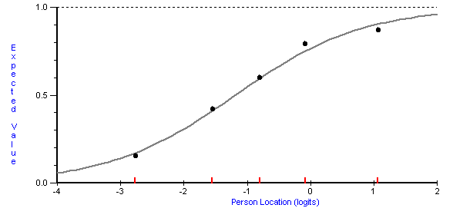

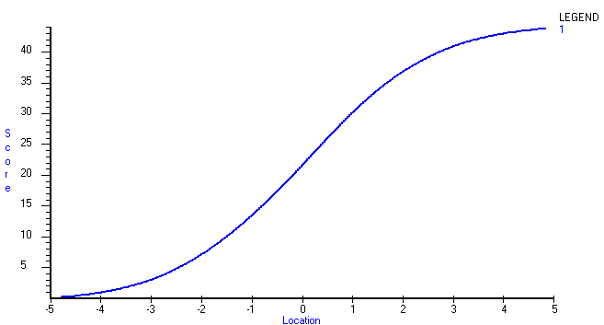

4 Points on the Raw Score Scale

4 Points on the Raw Score Scale

0.5 on the Rasch Scale

4 Points on the Raw Score Scale
1.0 Point on the Rasch Scale

- Numbers themselves do not mean much.
  - Is 10 meters a short distance? Long distance?

We need context to bring meaning to the measure: 10 meters.
However, 10 meters should always be 10 meters, no
matter who takes the measure or how it is taken.

- Is an item with a p-value of .90 easy or difficult?
… 90% passed the item

- Is a person with a score of 5 out of 50 items
low in ability?
… correctly answered 10% of the items

- Person-free item difficult
  - Locates the items on the ability continuum
- Item-free person ability
  - Locates the person on the ability continuum

- Places items and persons on the same scale –
the ITEM MAP

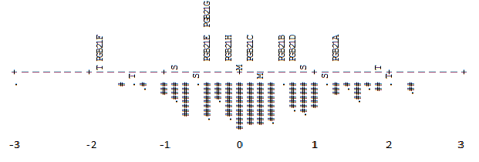

- Explains the construct; interpretation guide
- Enables design of items that will lead children to give responses that inform important levels of the construct map; identify relevant item features
- Provides criterion to analyze responses regarding
degree of consistency with construct map
- Item selection or retention should be based on
informed professional judgment

