EPSY 5221: Principles of Educational & Psychological Measurement
Interpreting Thresholds on Polytomous Item Response Models (Rasch Model)

With dichotomous items, which have a correct response, there is a single line that represents the probability of correct response – the Item Characteristic Curve (ICC). This is illustrated in the figure below. These two figures were estimated using Winsteps, a more flexible Rasch model software program.

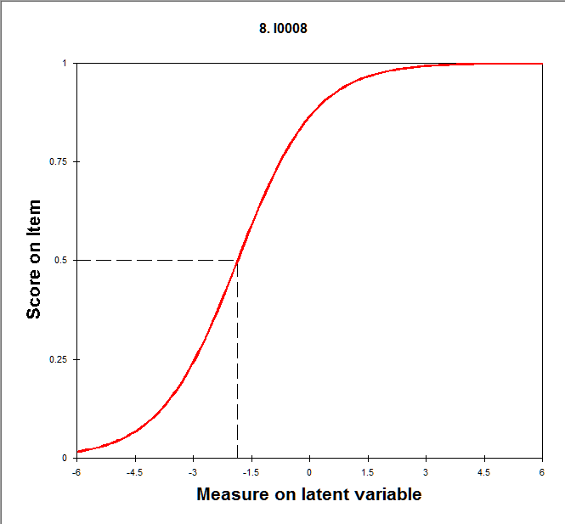

Item 8 is located at -1.86. This can be referred to as the item difficulty, but remember, difficulty is relative. This is better interpreted as the ability (-1.86) required to have a 50% probability of correct response.

When items are polytomous, or have multiple score points (perhaps a partial-credit item or rating scale item), there are multiple curves representing the response options. Consider the figure below.

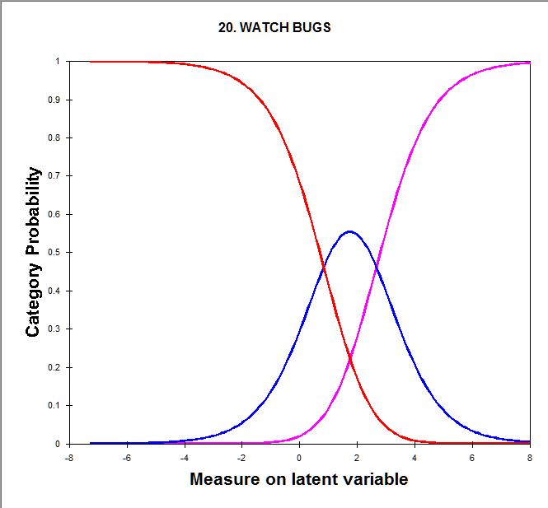

This is the category characteristic curve plot for the item 20 in Liking Science (Watch bugs). Recall that the response options included Dislike, Neutral, Like. For this set of curves, there are multiple ways to represent the location of the item. We can describe the location of each curve at some point, or we can describe the points at which the curves cross – these are called thresholds.

For polytomous items, just like dichotomous items, there is an overall item location value estimated. For item 20, the location is 1.75. The overall item location is useful for ordering items from easiest to Like to hardest to Like, given overall level of Liking Science. This activity, #20, requires a higher level of liking science than most activities. You really have to like science to like watching bugs.

Note: jMetrik estimates the item location for this item at 1.69. This is because item 12 is not estimated, since no kids responded Dislike to “Go to Museum.” This is a problem in the jMetrik ability to estimate items when one or more categories are not observed. Most IRT programs will allow items with different numbers of rating-scale points to be estimated together.

The location of the Liking Science items is in the middle of the two points where the curves cross. These “step” points are 0.84 and 2.66 for item 20. It indicates that if you have an overall level of Liking Science of less than 0.84, you are more likely to dislike watching bugs. If you have an overall level of Liking Science of 0.84 to 2.66, you are more likely to be neutral about watching bugs. But if you have an overall level of Liking Science of more than 2.66, you are more likely to like watching bugs.

In the Rasch model IRT analyses, it is more common to report these values as thresholds, which are subtracted from the item location of 1.75. So the lower threshold is -0.91 (0.84 – 1.75) and the upper threshold is +0.91 (2.66 – 1.75). You will see this in the Rasch analysis output from jMetrik. In Rasch analysis, these values are called Andrich Thresholds (after the person who introduced them).

The item map from jMetrik for Liking Science is displayed below. Notice that for each item, there are two points displayed. These two points correspond to the thresholds. However, as I review the values for these on the Item Map, they don’t necessarily align to the actual logits – the person histogram seems correct, but the items are not aligned in the same way (not sure what’s going on there). They are in the correct relative position (relative to other items).

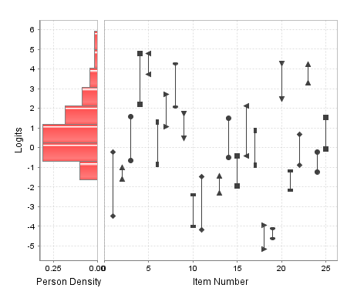

The two points for each item represent the two thresholds for the three rating-scale points. Note, however, that they are in the correct relative position compared across all items, but they are not on the same exact logit scale as persons.

