EPSY 5221 jMetrik IRT Lab

In this assignment we will conduct IRT analyses in jMetrik. We will again use the sample Exam 1 data including 5948 students who completed 56 multiple-choice items, scored dichotomously. We will also use the Liking Science data including 75 children who rated 25 items on a 3-point scale. For each of the following tasks, provide a written response and the corresponding displays as requested from the jMetrik output.

Coding the LIKING SCIENCE response data:
For the Rasch analysis, the item data must be recoded for the Liking Science responses.
- In the [Transform] tab select [Advanced Item Scoring]
- Send all items to the right using the [>>] tool
- In the Option and Score columns, enter 0 and 0, 1 and 1, 2 and 2, respectively. This fixes the item codes to their original values. The Rasch model will then use a partial-credit model, where Dislike receives no credit (0), Neutral receives partial credit (1), and Like receives full credit (2). This preserves the rating scale values so the Rasch model works.

Repeat tasks 1-7 below for both Exam-1 and Liking-Science data. Each of these tasks is worth 3 points for each data set (6 points in total per task; except question 8 which is for Exam 1 only). The lab is worth 45 points total.

- Report the mean score, standard deviation, and maximum and minimum scores for the total test. These descriptives should be for the IRT Theta scores, not the raw or observed scores.
  - Select the appropriate data table:
  - [Analyze] [Rasch Models].
    - In the Global tab: [for Exam 1: do not check “Ignore missing data]
[for Liking Science: check “Ignore missing data]
    - In the Item tab: [Save: Item Estimates, with a name like “Exam1Stats” or “LikingStats”]
    - In the Person tab: [Save: Person Estimates] and [Save: Person Fit Statistics]
    - Run
  - Select the appropriate data table:
[Analyze] [Descriptives] and select “theta” from the variables.
This will give you summary stats on the theta scores.

- Report Guttman reliability for the raw sum score and the reliability for the Person scores (theta). Show how this is computed, step-by-step, using true variance (adjusted variance) and observed variance with our theoretical definition of reliability. Interpret the reliability value.
  - Guttman reliability comes from the item analysis summary table you obtained in Lab 1.
  - The adjusted variance and observed variance come from the Rasch table you obtained in 1.b above. Remember: $Reliability= \frac{True Variance}{Observed Variance}$.

- Among the first 25 students, which student is the lowest ability student? What is his/her ability score and standard error? Does this student fit the model?
  - You will find this information by looking in the data file in the jMetrik data window.
  - Remember, ability is reported as Theta in the data file. Fit is measured by WMS (infit); these values should be less than 1.5.

- What is the most difficult item? What is the location statistic and standard error for this item? Provide an interpretation for this value – how do you communicate the meaning of the item “difficulty” value? Does this item fit the model?
  - You will find this information in two places:
    - The Rasch table produced in 1.b above (in the output).
    - The Item Stats table saved in jMetrik.
  - The item location is measured by the b-parameter, the item location on the theta scale.
  - Fit is measured in the same way with WMS and UMS.

- Which items, if any, do not fit the model? How do you know? What does it mean to fit or not fit the model? Consider all the items in the Item Stats tables for Exam 1 and Liking Science and review item fit.

- Compare the Item Characteristic Curves (ICCs) and Item Information Curves (IICs) from Exam 1 items: 1, 2, 3, 27, 32; and Liking Science items: 1, 2, 3, 4, 5. Discuss the differences you see in these curves (for each test separately), given the parameter(s) estimated.
  - Select one ICC graphic. Mark the location of the curve (the b parameter for Exam 1 and the steps for Liking Science). What does this parameter tell us about this item?
  - For each item, you will see the ICC always increasing across theta and the IIC which is normally distributed and centered at the location of the item (b-parameter).
  - To create the ICCs and IICs:
    - Select the ItemStats data table
    - [Graph] [IRT Plot]
    - Select all the items.
    - In the Item options, select [Characteristic Curve] and [Information Function]
    - In the Person options, select NO options
    - Curve Type: Category Probability

- Describe the Item Map: Where are items located on the theta scale compared to students? Do students have more or less ability compared to the difficulty of the items? This is like asking: are the items written at the level of student abilities?
  - Select the sample exam data set.
  - [Graph] [Item Map]
  - Select “theta” at the top of the file – this is for person locations.
  - Select the item stats data file for [Item Parameter Table] – this is for item locations.
  - You can give the graph a title: Exam 1 Item Map or Liking Science Item Map.
  - Run

- EXAM 1 ONLY: Estimate the NonParametric Curves of all Exam 1 items. Examine the curves for Exam 1 item 27. What is your interpretation of this result for Item 27? What does the Rasch analysis of this item suggest?
  - Select the Exam 1 data set.
  - [Analyze] [Nonparametric Curves]
  - Select all of the items for analysis, click [Run].
  - Examine the curve for Item 27.

DESCRIPTIVE STATISTICS
EXAM1

Theta
==============================
Statistic Value
------------------------------
N 5948.0000
Valid N 5948.0000
Min -4.2954
Max 5.4998
Mean 0.2485
Std. Dev. 1.0227
Skewness 0.2012
Kurtosis -0.0774
First Quartile -0.5659
Median 0.2494
Third Quartile 0.9325
IQR 1.4985
==============================

DESCRIPTIVE STATISTICS
LIKINGSCIENCE

Theta
==============================
Statistic Value
------------------------------
N 75.0000
Valid N 75.0000
Min -1.6536
Max 5.9251
Mean 0.8111
Std. Dev. 1.3519
Skewness 1.1745
Kurtosis 2.4481
First Quartile -0.0522
Median 0.5442
Third Quartile 1.4854
IQR 1.5376
==============================

EXAM 1 RESULTS

SCALE QUALITY STATISTICS
==================================================
Statistic Items Persons
--------------------------------------------------
Observed Variance 0.5704 1.0413
Observed Std. Dev. 0.7552 1.0204
Mean Square Error 0.0009 0.1013
Root MSE 0.0301 0.3182
Adjusted Variance 0.5695 0.9400
Adjusted Std. Dev. 0.7546 0.9695
Separation Index 25.0347 3.0467
Number of Strata 33.7130 4.3956
Reliability 0.9984 0.9027
==================================================

LIKING SCIENCE RESULTS

SCALE QUALITY STATISTICS
==================================================
Statistic Items Persons
--------------------------------------------------
Observed Variance 1.5208 1.4997
Observed Std. Dev. 1.2332 1.2246
Mean Square Error 0.0539 0.1597
Root MSE 0.2322 0.3996
Adjusted Variance 1.4669 1.3400
Adjusted Std. Dev. 1.2111 1.1576
Separation Index 5.2153 2.8970
Number of Strata 7.2871 4.1960
Reliability 0.9645 0.8935
==================================================

EXAM 1
First 25 Persons with Rasch Analysis Results

id | vsum | theta | stderr | extreme | wms | stdwms | ums | stdums
1 | 35 | 0.5791 | 0.2909 | No | 0.9655 | -0.3225 | 0.9673 | -0.1817
2 | 30 | 0.1688 | 0.2836 | No | 0.9716 | -0.3183 | 0.9225 | -0.6631
3 | 32 | 0.3305 | 0.2854 | No | 0.9892 | -0.0972 | 1.0032 | 0.0668
4 | 23 | -0.3975 | 0.2881 | No | 1.0675 | 0.7067 | 1.0501 | 0.4350
5 | 35 | 0.5791 | 0.2909 | No | 0.9105 | -0.9074 | 0.8463 | -1.0806
6 | 15 | -1.1202 | 0.3186 | No | 1.1630 | 1.0469 | 1.2873 | 1.3175
7 | 33 | 0.4123 | 0.2868 | No | 0.9352 | -0.7117 | 0.9204 | -0.5949
8 | 23 | -0.3975 | 0.2881 | No | 1.0855 | 0.8812 | 1.1079 | 0.8730
9 | 21 | -0.5659 | 0.2927 | No | 1.0586 | 0.5656 | 1.2690 | 1.8159
10 | 19 | -0.7408 | 0.2990 | No | 0.9847 | -0.0856 | 1.0078 | 0.1022
11 | 14 | -1.2239 | 0.3255 | No | 1.2772 | 1.5895 | 1.4576 | 1.8400
13 | 33 | 0.4123 | 0.2868 | No | 0.8831 | -1.3324 | 0.8336 | -1.3337
14 | 37 | 0.7517 | 0.2969 | No | 0.9122 | -0.7814 | 0.8464 | -0.9379
15 | 32 | 0.3305 | 0.2854 | No | 1.0335 | 0.4130 | 1.0054 | 0.0847
16 | 37 | 0.7517 | 0.2969 | No | 0.9301 | -0.6106 | 0.8801 | -0.7107
17 | 34 | 0.4951 | 0.2887 | No | 1.0269 | 0.3171 | 1.0772 | 0.6005
18 | 40 | 1.0270 | 0.3100 | No | 0.9147 | -0.6010 | 0.9044 | -0.4254
19 | 22 | -0.4810 | 0.2902 | No | 1.1478 | 1.4038 | 1.1482 | 1.1141
20 | 43 | 1.3331 | 0.3302 | No | 0.9893 | -0.0058 | 0.8742 | -0.4440
21 | 21 | -0.5659 | 0.2927 | No | 1.1933 | 1.7113 | 1.2185 | 1.5041
22 | 33 | 0.4123 | 0.2868 | No | 1.0504 | 0.5848 | 1.1367 | 1.0630
23 | 19 | -0.7408 | 0.2990 | No | 1.0279 | 0.2674 | 0.9804 | -0.0705
24 | 34 | 0.4951 | 0.2887 | No | 1.0174 | 0.2168 | 1.0034 | 0.0700
25 | 40 | 1.0270 | 0.3100 | No | 0.9779 | -0.1188 | 0.9400 | -0.2384
26 | 26 | -0.1524 | 0.2841 | No | 0.9168 | -0.9559 | 0.8797 | -1.0816

LIKING SCIENCE
First 25 Persons with Rasch Analysis Results

id | vsum | theta | stderr | extreme | wms | stdwms | ums | stdums
1 | 29 | 0.4928 | 0.3469 | No | 0.9575 | -0.0654 | 0.8411 | -0.3043
2 | 49 | 5.9902 | 1.8435 | Maximum | 0.0298 | -0.9922 | 0.0122 | -1.1611
3 | 33 | 0.9932 | 0.3618 | No | 0.4644 | -2.2833 | 0.4212 | -1.4353
4 | 26 | 0.1394 | 0.3402 | No | 0.7289 | -1.0341 | 0.6626 | -0.9927
5 | 18 | -0.7761 | 0.3418 | No | 0.8119 | -0.7034 | 1.4071 | 1.2126
6 | 23 | -0.2040 | 0.3371 | No | 1.6106 | 2.0819 | 2.5196 | 3.4495
7 | 43 | 2.6331 | 0.4796 | No | 1.8488 | 1.9359 | 1.1817 | 0.5038
8 | 32 | 0.8640 | 0.3573 | No | 1.0107 | 0.1317 | 0.8491 | -0.2070
9 | 23 | -0.2040 | 0.3371 | No | 1.4249 | 1.5384 | 2.0087 | 2.5325
10 | 27 | 0.2557 | 0.3420 | No | 0.7379 | -0.9811 | 0.6643 | -0.9466
11 | 34 | 1.1259 | 0.3669 | No | 1.0106 | 0.1325 | 0.8056 | -0.2516
12 | 16 | -1.0139 | 0.3483 | No | 1.6857 | 2.2459 | 3.8052 | 4.9796
13 | 23 | -0.2040 | 0.3371 | No | 0.7540 | -0.9548 | 0.7117 | -0.8847
14 | 22 | -0.3175 | 0.3369 | No | 1.7208 | 2.4066 | 1.8127 | 2.1610
15 | 26 | 0.1394 | 0.3402 | No | 0.9218 | -0.2115 | 1.5323 | 1.4374
16 | 42 | 2.4154 | 0.4546 | No | 0.5708 | -1.3311 | 0.3199 | -0.7610
17 | 46 | 3.5154 | 0.6295 | No | 1.4274 | 0.8893 | 0.4952 | 0.0283
18 | 40 | 2.0354 | 0.4195 | No | 0.9747 | 0.0285 | 0.5981 | -0.3802
19 | 31 | 0.7377 | 0.3533 | No | 0.9511 | -0.0847 | 0.7797 | -0.4200
20 | 25 | 0.0242 | 0.3387 | No | 1.0409 | 0.2409 | 0.9106 | -0.1608
21 | 27 | 0.2557 | 0.3420 | No | 0.2725 | -3.8203 | 0.2895 | -2.7121
22 | 34 | 1.1259 | 0.3669 | No | 0.3280 | -3.1417 | 0.3031 | -1.8075
23 | 39 | 1.8649 | 0.4067 | No | 0.4233 | -2.2830 | 0.3568 | -1.0275
24 | 31 | 0.7377 | 0.3533 | No | 0.9201 | -0.2008 | 0.7593 | -0.4770
25 | 41 | 2.2178 | 0.4351 | No | 1.0048 | 0.1261 | 0.6150 | -0.2781

EXAM 1
Item Stats for all 56 items

Item | b-parameter | Std. Error | WMS | Std. WMS | UMS | Std. UMS
item1 | -0.8456 | 0.0311 | 1.0394 | 2.7867 | 1.0222 | 0.8931
item2 | 0.0880 | 0.0287 | 1.1246 | 11.0826 | 1.1572 | 9.7177
item3 | -1.5068 | 0.0355 | 0.8975 | -5.3206 | 0.7718 | -6.6527
item4 | -0.1368 | 0.0289 | 1.1458 | 12.6070 | 1.2087 | 11.7853
item5 | -0.5340 | 0.0298 | 1.0678 | 5.4070 | 1.1223 | 5.7303
item6 | -0.9879 | 0.0318 | 0.9934 | -0.4328 | 0.9763 | -0.8701
item7 | 0.4267 | 0.0288 | 1.0680 | 6.0316 | 1.1087 | 6.8707
item8 | -1.8683 | 0.0391 | 0.8722 | -5.4130 | 0.6581 | -8.5054
item9 | 0.0178 | 0.0288 | 1.0648 | 5.8503 | 1.0753 | 4.6921
item10 | -1.4881 | 0.0353 | 0.8522 | -7.8917 | 0.7080 | -8.8459
item11 | -1.6247 | 0.0365 | 0.8575 | -7.0111 | 0.6664 | -9.5057
item12 | -0.0302 | 0.0288 | 1.0549 | 4.9575 | 1.0663 | 4.0806
item13 | -1.2355 | 0.0333 | 0.8548 | -8.9312 | 0.7491 | -8.6869
item14 | 0.3638 | 0.0287 | 1.0852 | 7.5814 | 1.1102 | 7.0270
item15 | -0.4729 | 0.0297 | 0.9261 | -6.3006 | 0.8986 | -5.2961
item16 | 0.4898 | 0.0289 | 1.0831 | 7.2595 | 1.1181 | 7.3449
item17 | 0.5558 | 0.0289 | 1.0551 | 4.7999 | 1.0667 | 4.1384
item18 | 0.2896 | 0.0287 | 1.0923 | 8.2527 | 1.1176 | 7.5175
item19 | -0.6203 | 0.0301 | 0.8418 | -13.1965 | 0.7605 | -12.0733
item20 | 0.2147 | 0.0287 | 1.0537 | 4.8804 | 1.0517 | 3.3707
item21 | -0.1268 | 0.0289 | 0.9779 | -2.0108 | 0.9614 | -2.3602
item22 | 0.5382 | 0.0289 | 1.0014 | 0.1240 | 1.0227 | 1.4418
item23 | 0.8790 | 0.0296 | 1.0500 | 3.9885 | 1.1298 | 6.8332
item24 | -0.1159 | 0.0289 | 0.8772 | -11.6349 | 0.8204 | -11.6279
item25 | 0.2090 | 0.0287 | 0.9648 | -3.2888 | 0.9497 | -3.3803
item26 | -1.0440 | 0.0321 | 0.9029 | -6.4997 | 0.8619 | -5.1389
item27 | 2.1981 | 0.0377 | 1.0787 | 3.3760 | 1.4500 | 9.8056
item28 | 0.7600 | 0.0293 | 1.1290 | 10.4133 | 1.1722 | 9.5076
item29 | 0.4948 | 0.0289 | 1.0791 | 6.9179 | 1.1042 | 6.4984
item30 | 0.6112 | 0.0290 | 1.0799 | 6.8166 | 1.1100 | 6.6022
item31 | 0.9160 | 0.0297 | 1.1612 | 12.2568 | 1.2366 | 11.8240
item32 | 1.1249 | 0.0305 | 1.1743 | 12.2070 | 1.3374 | 14.5113
item33 | -0.6212 | 0.0301 | 0.9788 | -1.6789 | 0.9453 | -2.5663
item34 | 0.2740 | 0.0287 | 0.9831 | -1.5617 | 0.9673 | -2.1886
item35 | -0.5242 | 0.0298 | 0.8804 | -10.1958 | 0.8059 | -10.1842

EXAM 1
Item Stats for all 56 items

Item | Difficulty | Std. Error | WMS | Std. WMS | UMS | Std. UMS
item36 | -0.2973 | 0.0292 | 0.8747 | -11.4651 | 0.8099 | -11.3366
item37 | 0.0888 | 0.0287 | 0.9321 | -6.4274 | 0.9257 | -4.9469
item38 | 0.6873 | 0.0292 | 1.1184 | 9.7874 | 1.1699 | 9.7066
item39 | 1.0650 | 0.0302 | 1.1236 | 8.9959 | 1.1933 | 8.9712
item40 | -0.2879 | 0.0292 | 1.0032 | 0.2816 | 1.0226 | 1.2627
item41 | -0.3944 | 0.0294 | 0.9189 | -7.1110 | 0.9174 | -4.4810
item42 | 0.1736 | 0.0287 | 1.0548 | 4.9913 | 1.0803 | 5.1600
item43 | -0.4152 | 0.0295 | 0.9958 | -0.3564 | 0.9930 | -0.3580
item44 | 0.8772 | 0.0296 | 1.0373 | 2.9873 | 1.0913 | 4.8699
item45 | 0.0880 | 0.0287 | 0.9273 | -6.8972 | 0.8966 | -6.9518
item46 | 0.0393 | 0.0287 | 0.8834 | -11.2056 | 0.8695 | -8.7611
item47 | 0.4284 | 0.0288 | 0.9990 | -0.0855 | 1.0055 | 0.3672
item48 | 0.3548 | 0.0287 | 0.9774 | -2.0802 | 0.9693 | -2.0476
item49 | 0.2748 | 0.0287 | 1.0542 | 4.9123 | 1.0770 | 4.9875
item50 | -0.3883 | 0.0294 | 0.8312 | -15.3227 | 0.7521 | -14.3933
item51 | -0.4985 | 0.0297 | 0.7965 | -18.0704 | 0.7066 | -16.2966
item52 | 0.2460 | 0.0287 | 0.9436 | -5.3040 | 0.9391 | -4.1140
item53 | 0.2518 | 0.0287 | 0.9756 | -2.2690 | 0.9696 | -2.0346
item54 | 0.8214 | 0.0295 | 1.1516 | 11.9326 | 1.2056 | 10.9069
item55 | 0.6441 | 0.0291 | 1.0284 | 2.4465 | 1.0545 | 3.2856
item56 | -0.4265 | 0.0295 | 0.8505 | -13.3103 | 0.7985 | -11.2305

LIKING SCIENCE
Item Stats for all 25 items

Item | Difficulty | Std. Error | WMS | Std. WMS | UMS | Std. UMS
q1 | -0.89 | 0.23 | 0.73 | -1.93 | 0.67 | -1.83
q2 | -0.61 | 0.2 | 0.76 | -1.49 | 0.56 | -1.43
q3 | 0.28 | 0.2 | 0.66 | -2.63 | 0.62 | -2.51
q4 | 1.8 | 0.21 | 0.99 | -0.02 | 0.98 | -0.05
q5 | 2.19 | 0.22 | 2.29 | 5.29 | 3.99 | 6.99
q6 | 0.16 | 0.2 | 0.88 | -0.79 | 0.82 | -1.01
q7 | 0.99 | 0.19 | 0.97 | -0.17 | 1.01 | 0.09
q8 | 1.64 | 0.21 | 1.17 | 1.14 | 1.23 | 1.42
q9 | 0.6 | 0.18 | 1.11 | 0.84 | 1.14 | 0.77
q10 | -1.57 | 0.26 | 0.78 | -1.09 | 0.56 | -1.14
q11 | -1.37 | 0.24 | 0.73 | -1.82 | 0.59 | -1.67
q12 | -1.14 | 0.33 | 0.82 | -0.94 | 0.58 | -0.89
q13 | -0.9 | 0.22 | 0.85 | -0.64 | 0.7 | -0.39
q14 | 0.29 | 0.2 | 0.87 | -0.87 | 0.81 | -1.14
q15 | -0.56 | 0.21 | 0.75 | -1.67 | 0.61 | -1.69
q16 | 0.47 | 0.21 | 1.09 | 0.66 | 1.05 | 0.36
q17 | 0.05 | 0.19 | 0.66 | -2.59 | 0.6 | -2.35
q18 | -2.26 | 0.41 | 1.23 | 0.58 | 1.18 | 0.55
q19 | -2.16 | 0.34 | 0.97 | 0.03 | 1.1 | 0.38
q20 | 1.75 | 0.21 | 1.36 | 2.14 | 1.8 | 3.72
q21 | -0.81 | 0.21 | 0.73 | -1.58 | 0.55 | -1.5
q22 | -0.01 | 0.19 | 0.8 | -1.39 | 0.71 | -1.48
q23 | 1.95 | 0.21 | 2.37 | 5.82 | 4.67 | 8.55
q24 | -0.32 | 0.19 | 0.79 | -1.41 | 0.69 | -1.21
q25 | 0.42 | 0.19 | 0.78 | -1.61 | 0.72 | -1.67

EXAM 1
ITEM ICCs AND IICs
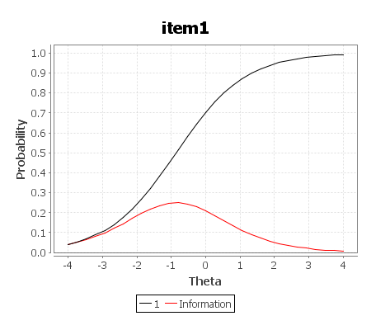

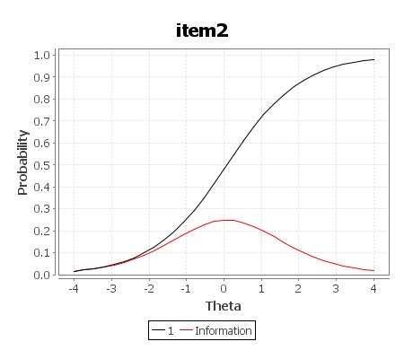
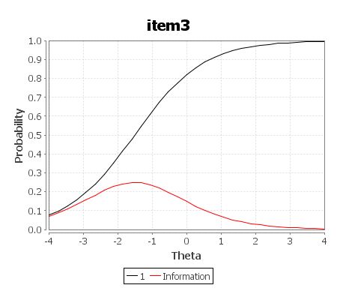

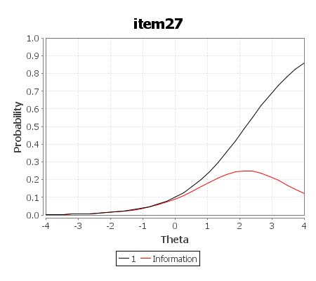

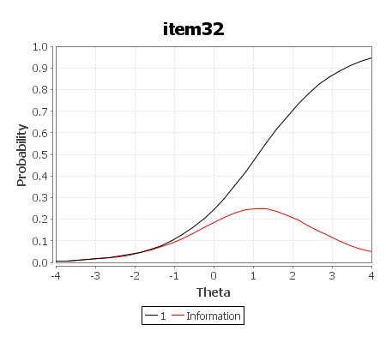

LIKING SCIENCE
ITEM ICCs AND IICs
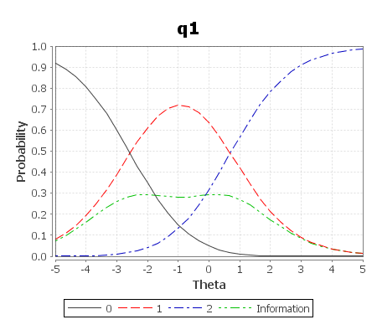

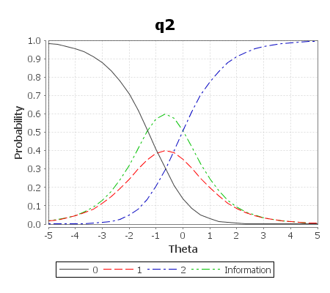
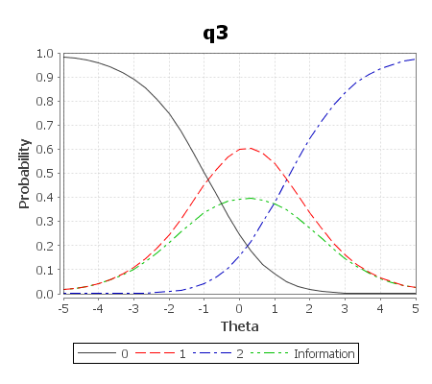

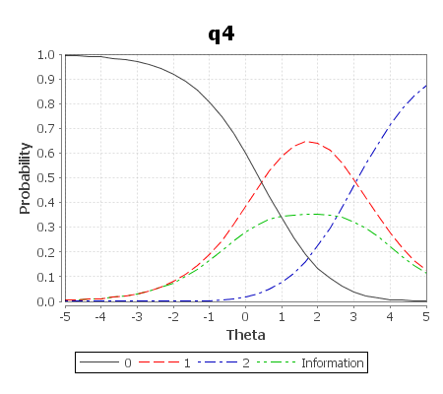
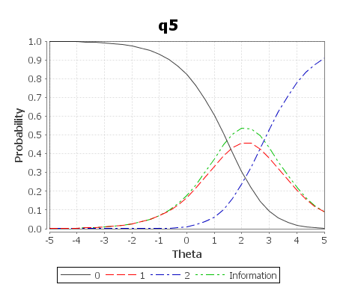

EXAM ITEM MAP
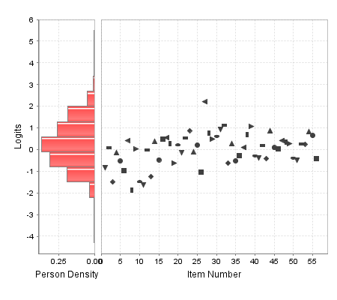
LIKING SCIENCE ITEM MAP
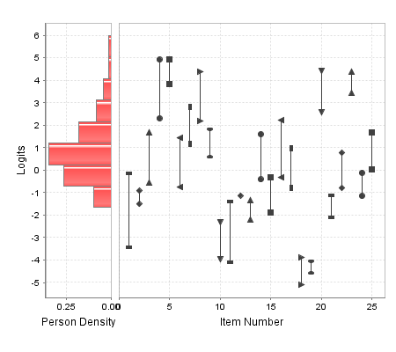

EXAM 1
Non-Parametric Curve for Item 27.

