Analysis of Rank Order Data in SPSS

breakfast.sav

In a classic study (Green and Rao, 1972), 21 Wharton School MBA students and their spouses were asked to rank 15 breakfast items in order of preference with 1="most preferred" to 15="least preferred." Their preferences were recorded under six different scenarios, from "Overall preference" to "Snack, with beverage only."

Variables
Menu scenarios
Gender
Toast pop-up
Buttered toast
English muffin and margarine
Jelly donut
Cinnamon toast
Blueberry muffin and margarine
Hard rolls and butter
Toast and marmalade
Buttered toast and jelly
Toast and margarine
Cinnamon bun
Danish pastry
Glazed donut
Coffee cake
Corn muffin and butter

Nonparametrics
Tests for K Related Samples

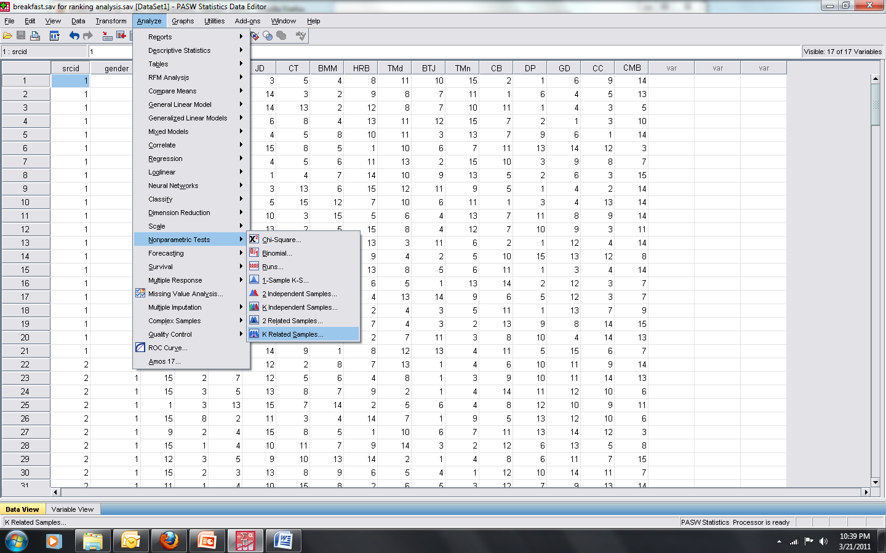

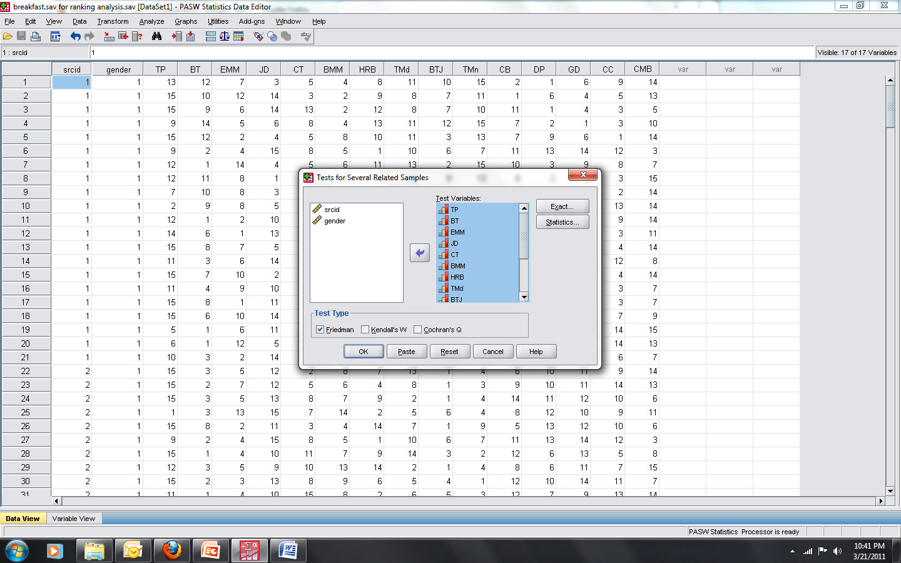

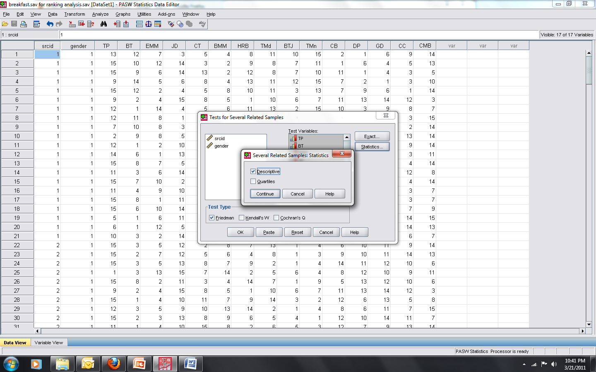

Descriptive Statistics
 | N | Mean | Std. Deviation | Minimum | Maximum
Toast pop-up | 252 | 11.30 | 3.808 | 1 | 15
Buttered toast | 252 | 6.63 | 4.518 | 1 | 15
English muffin and margarine | 252 | 7.25 | 3.854 | 1 | 15
Jelly donut | 252 | 8.94 | 4.432 | 1 | 15
Cinnamon toast | 252 | 8.33 | 3.692 | 1 | 15
Blueberry muffin and margarine | 252 | 7.01 | 3.443 | 1 | 15
Hard rolls and butter | 252 | 9.42 | 4.404 | 1 | 15
Toast and marmalade | 252 | 7.64 | 3.956 | 1 | 15
Buttered toast and jelly | 252 | 6.55 | 3.504 | 1 | 15
Toast and margarine | 252 | 8.18 | 4.560 | 1 | 15
Cinnamon bun | 252 | 7.94 | 4.073 | 1 | 15
Danish pastry | 252 | 6.50 | 4.681 | 1 | 15
Glazed donut | 252 | 8.25 | 4.425 | 1 | 15
Coffee cake | 252 | 6.65 | 4.342 | 1 | 15
Corn muffin and butter | 252 | 9.42 | 3.915 | 1 | 15

Friedman Test

Ranks
 | Mean Rank
Toast pop-up | 11.30
Buttered toast | 6.63
English muffin and margarine | 7.25
Jelly donut | 8.94
Cinnamon toast | 8.33
Blueberry muffin and margarine | 7.01
Hard rolls and butter | 9.42
Toast and marmalade | 7.64
Buttered toast and jelly | 6.55
Toast and margarine | 8.18
Cinnamon bun | 7.94
Danish pastry | 6.50
Glazed donut | 8.25
Coffee cake | 6.65
Corn muffin and butter | 9.42

Test Statisticsª
N | 252
Chi-Square | 324.152
df | 14
Asymp. Sig. | .000
a. Friedman Test

Friedman tests the null hypothesis that k related variables come from the same population. For each case, the k variables are ranked from 1 to k. The test statistic is based on these ranks.

