TABLE 3.1 LIKING FOR SCIENCE (Wright & Masters p. ZOU444WS.TXT Nov 6 15:55 2007
INPUT: 75 KIDS 25 ACTS MEASURED: 75 KIDS 25 ACTS 3 CATS WINSTEPS 3.64.0
--------------------------------------------------------------------------------

SUMMARY OF 74 MEASURED (NON-EXTREME) KIDS
+-----------------------------------------------------------------------------+
| RAW MODEL INFIT OUTFIT |
| SCORE COUNT MEASURE ERROR MNSQ ZSTD MNSQ ZSTD |
|-----------------------------------------------------------------------------|
| MEAN 31.4 25.0 .90 .39 .99 -.2 1.08 .1 |
| S.D. 8.4 .0 1.22 .10 .50 1.6 1.04 1.9 |
| MAX. 49.0 25.0 4.82 1.03 3.15 5.4 5.16 6.8 |
| MIN. 12.0 25.0 -1.61 .34 .29 -3.9 .20 -3.0 |
|-----------------------------------------------------------------------------|
| REAL RMSE .43 ADJ.SD 1.14 SEPARATION 2.67 KID RELIABILITY .88 |
|MODEL RMSE .40 ADJ.SD 1.15 SEPARATION 2.88 KID RELIABILITY .89 |
| S.E. OF KID MEAN = .14 |
+-----------------------------------------------------------------------------+
MAXIMUM EXTREME SCORE: 1 KIDS

SUMMARY OF 75 MEASURED (EXTREME AND NON-EXTREME) KIDS
+-----------------------------------------------------------------------------+
| RAW MODEL INFIT OUTFIT |
| SCORE COUNT MEASURE ERROR MNSQ ZSTD MNSQ ZSTD |
|-----------------------------------------------------------------------------|
| MEAN 31.7 25.0 .97 .40 |
| S.D. 8.6 .0 1.35 .19 |
| MAX. 50.0 25.0 6.07 1.84 |
| MIN. 12.0 25.0 -1.61 .34 |
|-----------------------------------------------------------------------------|
| REAL RMSE .47 ADJ.SD 1.26 SEPARATION 2.66 KID RELIABILITY .88 |
|MODEL RMSE .45 ADJ.SD 1.27 SEPARATION 2.82 KID RELIABILITY .89 |
| S.E. OF KID MEAN = .16 |
+-----------------------------------------------------------------------------+
KID RAW SCORE-TO-MEASURE CORRELATION = .96
CRONBACH ALPHA (KR-20) KID RAW SCORE RELIABILITY = .89

SUMMARY OF 25 MEASURED (NON-EXTREME) ACTS
+-----------------------------------------------------------------------------+
| RAW MODEL INFIT OUTFIT |
| SCORE COUNT MEASURE ERROR MNSQ ZSTD MNSQ ZSTD |
|-----------------------------------------------------------------------------|
| MEAN 93.0 74.0 .00 .23 1.02 -.2 1.08 .0 |
| S.D. 30.9 .0 1.41 .06 .45 2.3 .87 2.8 |
| MAX. 143.0 74.0 2.42 .47 2.41 6.3 4.11 9.0 |
| MIN. 35.0 74.0 -3.15 .19 .55 -3.5 .49 -3.0 |
|-----------------------------------------------------------------------------|
| REAL RMSE .26 ADJ.SD 1.38 SEPARATION 5.32 ACT RELIABILITY .97 |
|MODEL RMSE .24 ADJ.SD 1.39 SEPARATION 5.86 ACT RELIABILITY .97 |
| S.E. OF ACT MEAN = .29 |
+-----------------------------------------------------------------------------+
UMEAN=.000 USCALE=1.000
ACT RAW SCORE-TO-MEASURE CORRELATION = -.98
1850 DATA POINTS. APPROXIMATE LOG-LIKELIHOOD CHI-SQUARE: 2657.91

TABLE 12.2 LIKING FOR SCIENCE (Wright & Masters p ZOU444WS.TXT Nov 6 15:55 2007
INPUT: 75 KIDS 25 ACTS MEASURED: 75 KIDS 25 ACTS 3 CATS WINSTEPS 3.64.0
--------------------------------------------------------------------------------
KIDS MAP OF ACTS
<more>|<rare>
5 X +
X |
|
|
|
|
4 X +
|
X |
|
T|
X |
3 X +
|T
X |
XX | FIND BOTTLES AND CANS
XX |
XX S| WATCH A RAT
2 XXX +
XX | WATCH BUGS
XX | LOOK IN SIDEWALK CRACKS
WATCH GRASS CHANGE
XX |
XX |S
XXXXXX | WATCH ANIMAL MOVE
1 XXX +
XXX M|
XXXXX | LEARN WEED NAMES
MAKE A MAP
XXX | LOOK AT PICTURES OF PLANTS
READ BOOKS ON PLANTS
TALK W/FRIENDS ABOUT PLANTS
XXXXXXXXXXX | LOOK UP STRANGE ANIMAL OR PLANT
XXXX | FIND OUT WHAT ANIMALS EAT
WATCH WHAT ANIMALS EAT
0 XXX +M
XXXXX |
S| FIND OUT WHAT FLOWERS LIVE ON
WATCH BIRDS
X | READ ANIMAL STORIES
XX | READ BOOKS ON ANIMALS
| WATCH BIRD MAKE NEST
-1 XX + FIND WHERE ANIMAL LIVES
|
XX |S GROW GARDEN
T| LISTEN TO BIRD SING
X |
|
-2 + GO TO MUSEUM
|
|
| GO TO ZOO
|
|T
-3 +
| GO ON PICNIC
|
|
|
|
-4 +
<less>|<frequ>

TABLE 13.1 LIKING FOR SCIENCE (Wright & Masters p ZOU444WS.TXT Nov 6 15:55 2007
INPUT: 75 KIDS 25 ACTS MEASURED: 75 KIDS 25 ACTS 3 CATS WINSTEPS 3.64.0
--------------------------------------------------------------------------------
KID: REAL SEP.: 2.67 REL.: .88 ... ACT: REAL SEP.: 5.32 REL.: .97

ACT STATISTICS: MEASURE ORDER

+-------------------------------------------------------------------------------------------------------------+
|ENTRY RAW MODEL| INFIT | OUTFIT |PTMEA|EXACT MATCH| |
|NUMBER SCORE COUNT MEASURE S.E. |MNSQ ZSTD|MNSQ ZSTD|CORR.| OBS% EXP%| ACT |
|------------------------------------+----------+----------+-----+-----------+--------------------------------|
| 5 35 74 2.42 .22|2.30 5.6|3.62 7.3| .05| 52.7 68.1| FIND BOTTLES AND CANS |
| 23 40 74 2.18 .21|2.41 6.3|4.11 9.0| .00| 40.5 65.0| WATCH A RAT |
| 20 48 74 1.83 .20|1.33 2.0|1.82 3.7| .42| 54.1 61.1| WATCH BUGS |
| 4 50 74 1.75 .20| .89 -.7| .91 -.4| .60| 67.6 60.1| WATCH GRASS CHANGE |
| 8 52 74 1.67 .20|1.10 .7|1.21 1.2| .51| 47.3 59.0| LOOK IN SIDEWALK CRACKS |
| 7 67 74 1.10 .19| .97 -.1|1.01 .1| .59| 50.0 54.7| WATCH ANIMAL MOVE |
| 9 78 74 .71 .19|1.18 1.3|1.17 1.0| .53| 55.4 56.6| LEARN WEED NAMES |
| 16 81 74 .60 .19| .97 -.2| .95 -.3| .51| 60.8 57.3| MAKE A MAP |
| 25 83 74 .53 .19| .80 -1.5| .74 -1.6| .66| 66.2 57.4| TALK W/FRIENDS ABOUT PLANTS |
| 3 86 74 .42 .19| .57 -3.5| .54 -3.0| .72| 73.0 57.7| READ BOOKS ON PLANTS |
| 14 86 74 .42 .19| .82 -1.3| .75 -1.4| .62| 67.6 57.7| LOOK AT PICTURES OF PLANTS |
| 6 89 74 .31 .19| .81 -1.4| .76 -1.4| .61| 70.3 58.3| LOOK UP STRANGE ANIMAL OR PLANT|
| 17 93 74 .16 .19| .65 -2.7| .59 -2.4| .70| 73.0 58.7| WATCH WHAT ANIMALS EAT |
| 22 95 74 .08 .19| .83 -1.2| .74 -1.4| .63| 71.6 58.6| FIND OUT WHAT ANIMALS EAT |
| 24 105 74 -.31 .20| .90 -.6| .79 -.9| .60| 63.5 60.8| FIND OUT WHAT FLOWERS LIVE ON |
| 1 107 74 -.40 .21| .55 -3.5| .49 -2.5| .64| 77.0 61.7| WATCH BIRDS |
| 15 109 74 -.48 .21| .78 -1.5| .64 -1.6| .61| 73.0 62.2| READ ANIMAL STORIES |
| 2 114 74 -.71 .22| .93 -.4| .72 -1.0| .58| 74.3 64.4| READ BOOKS ON ANIMALS |
| 21 117 74 -.85 .22| .84 -.9| .65 -1.3| .58| 75.7 66.2| WATCH BIRD MAKE NEST |
| 11 119 74 -.96 .23| .63 -2.4| .49 -1.9| .59| 77.0 68.3| FIND WHERE ANIMAL LIVES |
| 13 125 74 -1.29 .25|1.22 1.1| .94 .0| .47| 78.4 74.3| GROW GARDEN |
| 10 128 74 -1.49 .26| .78 -1.1| .57 -1.1| .50| 78.4 77.1| LISTEN TO BIRD SING |
| 12 135 74 -2.04 .31| .70 -1.2| .51 -1.0| .45| 86.5 83.7| GO TO MUSEUM |
| 19 139 74 -2.48 .36|1.08 .4|1.10 .4| .30| 90.5 88.0| GO TO ZOO |
| 18 143 74 -3.15 .47|1.50 1.2|1.23 .5| .14| 94.6 93.4| GO ON PICNIC |
|------------------------------------+----------+----------+-----+-----------+--------------------------------|
| MEAN 93.0 74.0 .00 .23|1.02 -.2|1.08 .0| | 68.8 65.2| |
| S.D. 30.9 .0 1.41 .06| .45 2.3| .87 2.8| | 13.1 10.2| |
+-------------------------------------------------------------------------------------------------------------+

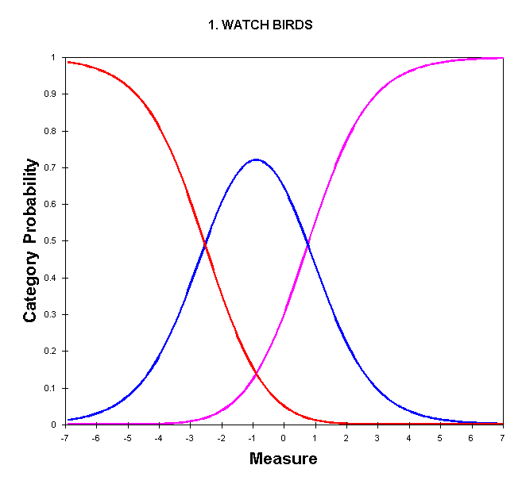

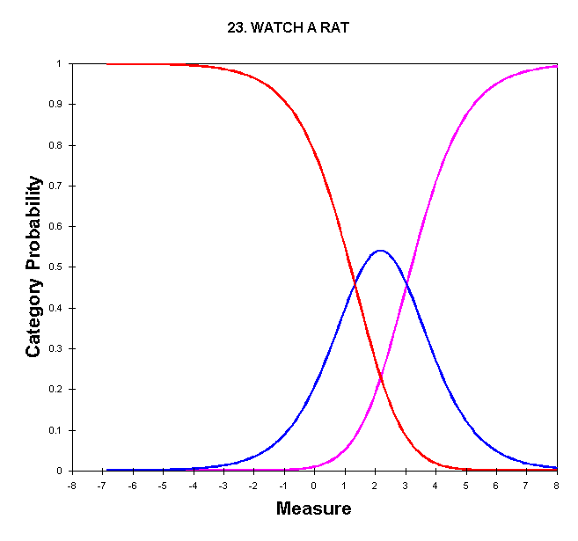
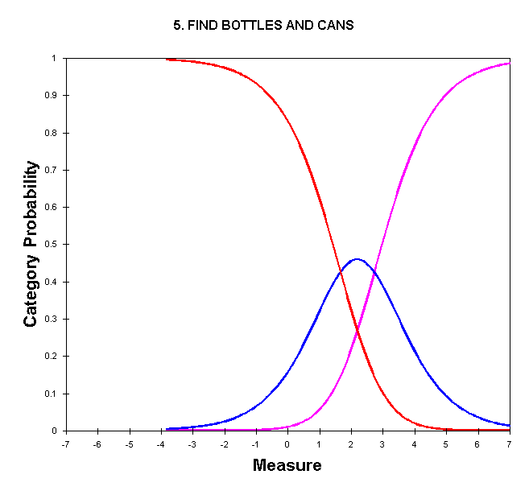

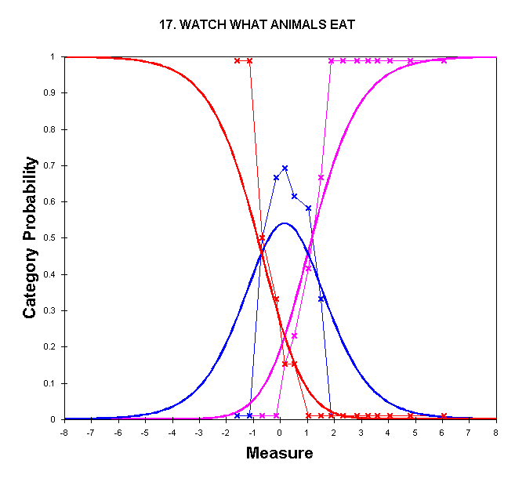
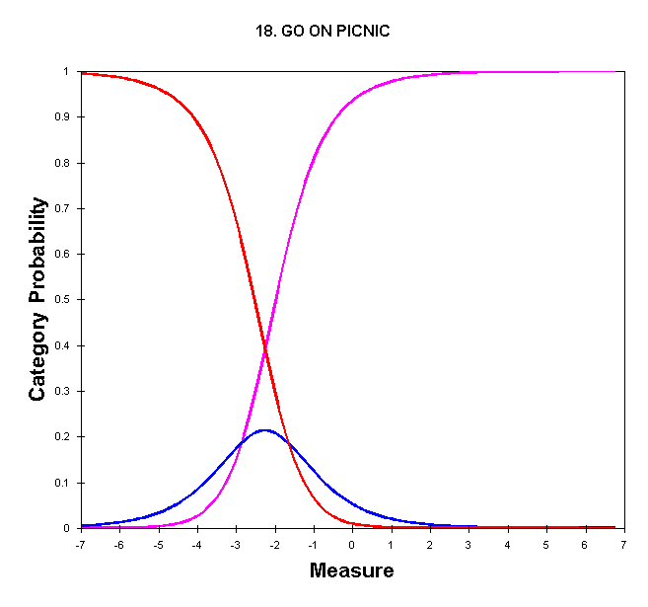

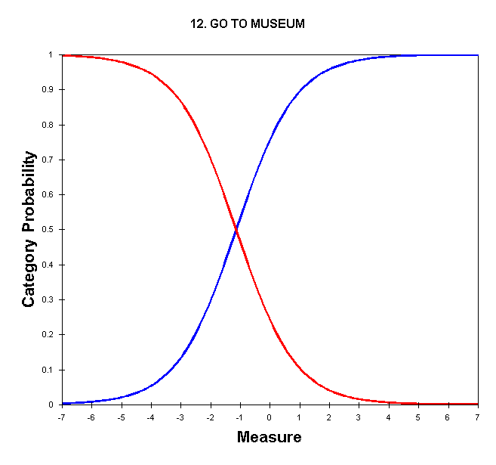

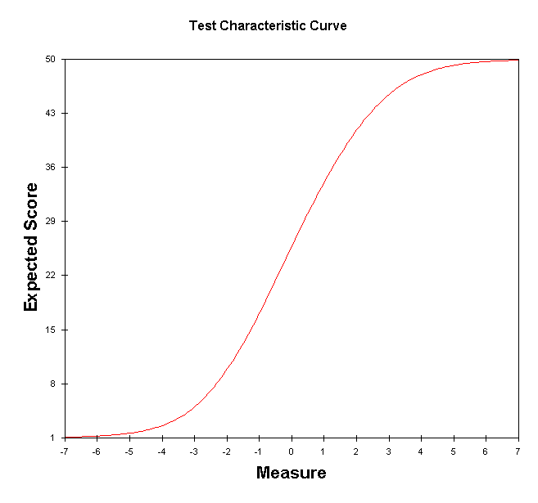

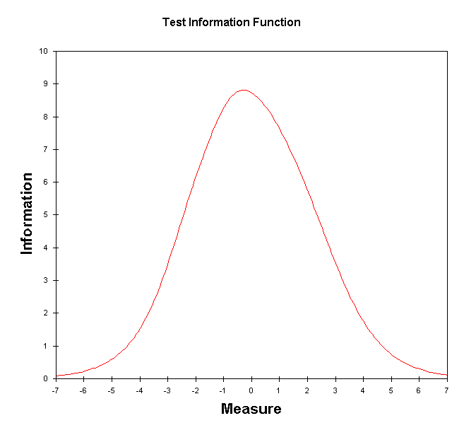

TABLE 16.3 LIKING FOR SCIENCE (Wright & Masters p ZOU444WS.TXT Nov 6 15:55 2007
INPUT: 75 KIDS 25 ACTS MEASURED: 75 KIDS 25 ACTS 3 CATS WINSTEPS 3.64.0
--------------------------------------------------------------------------------
ACTS MAP OF KIDS
<rare>|<more>
5 + ROSSNER, LAWRENCE F.
| FATALE, NATASHA
|
|
4 + PASTER, RUTH
|
| SCHATTNER, GAIL
|
T|
| DOEPPNER, TOM
3 + MCLOUGHLIN, BILLY
|T
| WRIGHT, BENJAMIN
X | BUFF, MARGE BABY CHAZELLE, BERNIE
| CLAPP, LB SEILER, KAREN
X S| ERNST, RICHARD MAX SQURREL, ROCKY J.
2 + CLAPP, CHARLIE EASTWOOD, CLINT
VROOM, JEFF
X | BADENOV, BORIS KENT, CLARK
XX | MOOSE, BULLWINKLE ROSSNER, BESS
| MAN, SPIDER PATRIARCA, RAY
|S CORLEONE, VITO SQUILLY, MICHAEL
X | BECKER, SELWIN CLAPP, DOCENT
HOGAN, KATHLEEN HSIEH, PAUL FRED
REISS, STEVE ROSSNER, TOBY G.
1 + BLOFELD, VILLAIN LAMBERT, MD., ROSS W.
STOLLER, DAVE
M| FONTANILLA, HAMES LEADER, FEARLESS
TOZER, AMY ELIZABETH
XX | BABBOO, BABOO CORLEONE, MICHAEL
PINHEAD, ZIPPY ROSSNER, MARC DANIEL
SABILE, JACK
XXX | ALLEN, PETER MALAPROP, MRS.
SQUILLY, BAY OF
X | AIREHEAD, JOHN BEISER, ED
CIANCI, BUDDY DENNY, DON
DYSON, STEPHIE NINA EISEN, NORM L.
HSIEH, DANIEL SEB RINZLER, JAMES
ROSSNER, MICHAEL T. SANDBERG, RYNE
STULTZ, NEWELL
XX | ANGUIANO, ROB MULLER, JEFF
PAULING, LINUS ROSSNER, JACK
0 +M AMIRAULT, ZIPPY DRISKEL, MICHAEL
NEIMAN, RAYMOND
| HWA, NANCY MARIE LIEBERMAN, BENJAMIN
ROSSNER, TR CAT SCHULZ, MATTHEW
VAN DAM, ANDY
XX S|
X | BAUDET, GERARD
X | BOND, JAMES ROSSNER, REBECCA A.
X |
-1 X + LIEBERMAN, DANIEL NORDGREN, JAN SWEDE
|
X |S JACKSON, SOLOMON LANDMAN, ALAN
X T|
| SABOL, ANDREW
|
-2 X +
|
|
X |
|
|T
-3 +
X | <frequ>|<less>
TABLE 17.1 LIKING FOR SCIENCE (Wright & Masters p ZOU444WS.TXT Nov 6 15:55 2007
INPUT: 75 KIDS 25 ACTS MEASURED: 75 KIDS 25 ACTS 3 CATS WINSTEPS 3.64.0
--------------------------------------------------------------------------------
KID: REAL SEP.: 2.67 REL.: .88 ... ACT: REAL SEP.: 5.32 REL.: .97

KID STATISTICS: MEASURE ORDER

+---------------------------------------------------------------------------------------------------+
|ENTRY RAW MODEL| INFIT | OUTFIT |PTMEA|EXACT MATCH| |
|NUMBER SCORE COUNT MEASURE S.E. |MNSQ ZSTD|MNSQ ZSTD|CORR.| OBS% EXP%| KID |
|------------------------------------+----------+----------+-----+-----------+----------------------|
| 2 50 25 6.07 1.84| MAXIMUM ESTIMATED MEASURE | | ROSSNER, LAWRENCE F. |
| 41 49 25 4.82 1.03| .85 .2| .25 -.3| .32| 96.0 96.1| FATALE, NATASHA |
| 34 48 25 4.06 .75| .61 -.5| .20 -.4| .48| 92.0 92.3| PASTER, RUTH |
| 17 47 25 3.59 .63|1.17 .5| .39 -.2| .46| 92.0 88.0| SCHATTNER, GAIL |
| 50 46 25 3.24 .56| .54 -1.1| .29 -.6| .58| 92.0 84.8| DOEPPNER, TOM |
| 45 45 25 2.95 .51|1.17 .5| .50 -.3| .55| 84.0 81.9| MCLOUGHLIN, BILLY |
| 7 44 25 2.71 .48|1.84 1.9|1.10 .4| .43| 76.0 79.3| WRIGHT, BENJAMIN |
| 16 43 25 2.49 .45| .52 -1.5| .31 -1.0| .70| 92.0 77.9| BUFF, MARGE BABY |
| 48 43 25 2.49 .45| .86 -.3| .49 -.6| .63| 84.0 77.9| CHAZELLE, BERNIE |
| 25 42 25 2.29 .43| .96 .0| .61 -.4| .61| 84.0 76.2| SEILER, KAREN |
| 59 42 25 2.29 .43| .90 -.2| .53 -.6| .63| 80.0 76.2| CLAPP, LB |
| 18 41 25 2.11 .42| .93 -.1| .58 -.6| .67| 80.0 74.0| ERNST, RICHARD MAX |
| 39 41 25 2.11 .42| .63 -1.2| .44 -.9| .71| 80.0 74.0| SQURREL, ROCKY J. |
| 23 40 25 1.95 .40| .45 -2.1| .38 -1.2| .71| 76.0 72.2| VROOM, JEFF |
| 56 40 25 1.95 .40| .79 -.6| .54 -.8| .70| 76.0 72.2| EASTWOOD, CLINT |
| 57 40 25 1.95 .40|1.10 .4| .70 -.4| .70| 76.0 72.2| CLAPP, CHARLIE |
| 40 39 25 1.79 .39| .68 -1.1| .50 -1.0| .74| 76.0 69.9| BADENOV, BORIS |
| 70 39 25 1.79 .39|1.02 .2| .69 -.5| .67| 68.0 69.9| KENT, CLARK |
| 33 38 25 1.64 .38|1.15 .6| .82 -.2| .63| 72.0 67.2| ROSSNER, BESS |
| 38 38 25 1.64 .38| .57 -1.7| .45 -1.3| .71| 80.0 67.2| MOOSE, BULLWINKLE |
| 43 37 25 1.50 .37| .84 -.5| .62 -.8| .72| 68.0 64.9| MAN, SPIDER |
| 74 37 25 1.50 .37|1.18 .7| .88 -.1| .69| 52.0 64.9| PATRIARCA, RAY |
| 60 36 25 1.36 .37| .49 -2.2| .43 -1.5| .74| 76.0 63.5| SQUILLY, MICHAEL |
| 64 36 25 1.36 .37| .61 -1.6| .50 -1.3| .76| 76.0 63.5| CORLEONE, VITO |
| 11 35 25 1.23 .36| .99 .1| .78 -.4| .74| 60.0 62.2| HSIEH, PAUL FRED |
| 22 35 25 1.23 .36| .34 -3.2| .33 -2.1| .80| 92.0 62.2| HOGAN, KATHLEEN |
| 58 35 25 1.23 .36| .72 -1.0| .60 -1.0| .75| 68.0 62.2| CLAPP, DOCENT |
| 3 34 25 1.10 .36| .44 -2.6| .39 -1.9| .79| 88.0 61.8| ROSSNER, TOBY G. |
| 51 34 25 1.10 .36| .72 -1.1| .60 -1.1| .78| 64.0 61.8| REISS, STEVE |
| 26 25 25 .03 .34| .73 -1.1|1.33 1.1| .00| 60.0 59.6| NEIMAN, RAYMOND |
| 36 25 25 .03 .34| .81 -.7|1.25 .9| .58| 80.0 59.6| AMIRAULT, ZIPPY |
| 55 25 25 .03 .34| .92 -.2| .89 -.3| .61| 68.0 59.6| DRISKEL, MICHAEL |
| 6 24 25 -.08 .34|1.62 2.1|2.39 3.5| .20| 56.0 59.5| ROSSNER, TR CAT |
| 9 24 25 -.08 .34|1.41 1.5|1.83 2.4| .37| 52.0 59.5| SCHULZ, MATTHEW |
| 13 24 25 -.08 .34| .79 -.8| .77 -.7| .68| 56.0 59.5| LIEBERMAN, BENJAMIN |
| 47 24 25 -.08 .34|1.27 1.1|1.68 2.0| .51| 60.0 59.5| VAN DAM, ANDY |
| 14 23 25 -.20 .34|1.77 2.5|1.76 2.2| .49| 48.0 59.6| HWA, NANCY MARIE |
| 49 21 25 -.43 .34|1.53 1.8|2.48 3.6| .02| 52.0 59.0| BAUDET, GERARD |
| 5 19 25 -.67 .35| .88 -.4|1.33 1.0| .48| 60.0 60.7| ROSSNER, REBECCA A. |
| 68 19 25 -.67 .35|1.03 .2| .93 -.1| .70| 68.0 60.7| BOND, JAMES |
| 12 17 25 -.92 .36|1.87 2.7|3.51 4.7| .19| 44.0 62.7| LIEBERMAN, DANIEL |
| 30 16 25 -1.05 .36|1.06 .3|1.19 .6| .70| 68.0 64.1| NORDGREN, JAN SWEDE |
| 29 14 25 -1.32 .37|1.40 1.3|3.94 4.6| .30| 64.0 65.8| LANDMAN, ALAN |
| 72 14 25 -1.32 .37|2.02 2.9|5.16 5.7| .04| 60.0 65.8| JACKSON, SOLOMON |
| 53 12 25 -1.61 .39| .98 .0|1.81 1.6| .45| 76.0 68.7| SABOL, ANDREW |
|------------------------------------+----------+----------+-----+-----------+----------------------|
| MEAN 31.7 25.0 .97 .40| .99 -.2|1.08 .1| | 68.8 65.2| |
| S.D. 8.6 .0 1.35 .19| .50 1.6|1.04 1.9| | 13.5 8.4| |
+---------------------------------------------------------------------------------------------------+

TABLE 20.2 LIKING FOR SCIENCE (Wright & Masters p ZOU444WS.TXT Nov 6 15:55 2007
INPUT: 75 KIDS 25 ACTS MEASURED: 75 KIDS 25 ACTS 3 CATS WINSTEPS 3.64.0
--------------------------------------------------------------------------------

TABLE OF SAMPLE NORMS (500/100) AND FREQUENCIES CORRESPONDING TO COMPLETE TEST
+---------------------------------------------------------------------------+
| SCORE MEASURE S.E.|NORMED S.E. FREQUENCY % CUM.FREQ. % PERCENTILE|
|------------------------+--------------------------------------------------|
| 0 -6.26E 1.85| -37 138 0 .0 0 .0 0 |
| 1 -4.99 1.05| 58 78 0 .0 0 .0 0 |
| 2 -4.20 .77| 116 57 0 .0 0 .0 0 |
| 3 -3.70 .65| 153 48 0 .0 0 .0 0 |
| 4 -3.32 .58| 181 43 0 .0 0 .0 0 |
| 5 -3.01 .53| 204 39 0 .0 0 .0 0 |
| 6 -2.75 .50| 224 37 0 .0 0 .0 0 |
| 7 -2.52 .47| 241 35 0 .0 0 .0 0 |
| 8 -2.31 .45| 257 33 0 .0 0 .0 0 |
| 9 -2.12 .43| 271 32 0 .0 0 .0 0 |
| 10 -1.94 .41| 284 31 0 .0 0 .0 0 |
| 11 -1.77 .40| 296 30 0 .0 0 .0 0 |
| 12 -1.62 .39| 308 29 1 1.3 1 1.3 1 |
| 13 -1.47 .38| 319 28 0 .0 1 1.3 1 |
| 14 -1.32 .37| 330 28 2 2.7 3 4.0 3 |
| 15 -1.19 .37| 340 27 0 .0 3 4.0 4 |
| 16 -1.05 .36| 350 27 1 1.3 4 5.3 5 |
| 17 -.92 .36| 360 27 1 1.3 5 6.7 6 |
| 18 -.80 .35| 369 26 0 .0 5 6.7 7 |
| 19 -.67 .35| 378 26 2 2.7 7 9.3 8 |
| 20 -.55 .35| 387 26 0 .0 7 9.3 9 |
| 21 -.43 .34| 396 26 1 1.3 8 10.7 10 |
| 22 -.32 .34| 405 25 0 .0 8 10.7 11 |
| 23 -.20 .34| 413 25 1 1.3 9 12.0 11 |
| 24 -.08 .34| 422 25 4 5.3 13 17.3 15 |
| 25 .03 .34| 431 25 3 4.0 16 21.3 19 |
| 26 .15 .34| 439 25 4 5.3 20 26.7 24 |
| 27 .26 .34| 448 25 6 8.0 26 34.7 31 |
| 28 .38 .34| 456 25 5 6.7 31 41.3 38 |
| 29 .49 .34| 465 25 3 4.0 34 45.3 43 |
| 30 .61 .34| 474 26 3 4.0 37 49.3 47 |
| 31 .73 .35| 482 26 2 2.7 39 52.0 51 |
| 32 .85 .35| 491 26 3 4.0 42 56.0 54 |
| 33 .97 .35| 501 26 3 4.0 45 60.0 58 |
| 34 1.10 .36| 510 27 3 4.0 48 64.0 62 |
| 35 1.23 .36| 519 27 3 4.0 51 68.0 66 |
| 36 1.36 .37| 529 27 2 2.7 53 70.7 69 |
| 37 1.50 .37| 540 28 2 2.7 55 73.3 72 |
| 38 1.64 .38| 550 28 2 2.7 57 76.0 75 |
| 39 1.79 .39| 561 29 2 2.7 59 78.7 77 |
| 40 1.95 .40| 573 30 3 4.0 62 82.7 81 |
| 41 2.12 .42| 586 31 2 2.7 64 85.3 84 |
| 42 2.30 .43| 599 32 2 2.7 66 88.0 87 |
| 43 2.49 .45| 614 34 2 2.7 68 90.7 89 |
| 44 2.71 .48| 630 36 1 1.3 69 92.0 91 |
| 45 2.96 .51| 648 38 1 1.3 70 93.3 93 |
| 46 3.25 .56| 669 42 1 1.3 71 94.7 94 |
| 47 3.60 .63| 696 47 1 1.3 72 96.0 95 |
| 48 4.07 .75| 731 56 1 1.3 73 97.3 97 |
| 49 4.83 1.03| 787 77 1 1.3 74 98.7 98 |
| 50 6.08E 1.84| 880 137 1 1.3 75 100.0 99 |
+---------------------------------------------------------------------------+
THE NORMED SCALE IS EQUIVALENT TO UIMEAN= 428.23 USCALE= 74.32

DIF class specification is: DIF=@GENDER
+--------------------------------------------------------------------------------------------------------------------------+
| KID DIF DIF KID DIF DIF DIF JOINT MantelHanzl ACT |
| CLASS MEASURE S.E. CLASS MEASURE S.E. CONTRAST S.E. t d.f. Prob. Prob. Size Number Name |
|--------------------------------------------------------------------------------------------------------------------------|
| f -.91 .37 m -.89 .30 -.02 .48 -.04 72 .9664 .4223 +. 1 WATCH BIRDS |
| f .07 .29 m -1.21 .31 1.27 .42 3.04 72 .0033 .0044 +. 2 READ BOOKS ON ANIMALS |
| f -.08 .33 m .50 .25 -.57 .41 -1.39 72 .1695 .8734 +. 3 READ BOOKS ON PLANTS |
| f 1.19 .33 m 2.24 .29 -1.05 .44 -2.40 72 .0190 .0524 -. 4 WATCH GRASS CHANGE |
| f 2.17 .35 m 2.19 .28 -.02 .44 -.05 72 .9594 .5671 -. 5 FIND BOTTLES AND CANS |
| f .24 .32 m .11 .26 .13 .41 .32 72 .7495 .4467 -. 6 LOOK UP STRANGE ANIMAL OR PLANT|
| f 1.10 .31 m .93 .24 .18 .39 .45 72 .6516 .4550 .00 7 WATCH ANIMAL MOVE |
| f 1.36 .32 m 1.83 .27 -.48 .42 -1.13 72 .2603 .6503 +. 8 LOOK IN SIDEWALK CRACKS |
| f .55 .29 m .63 .23 -.08 .38 -.22 72 .8241 .3797 -. 9 LEARN WEED NAMES |
| f -1.39 .39 m -1.70 .35 .31 .52 .59 72 .5544 .2524 .00 10 LISTEN TO BIRD SING |
| f -1.01 .37 m -1.63 .33 .62 .49 1.27 72 .2081 .6593 -. 11 FIND WHERE ANIMAL LIVES |
| f -.92 .49 m -1.30 .44 .39 .66 .58 72 .5605 .2189 +. 12 GO TO MUSEUM |
| f -1.03 .36 m -.82 .27 -.21 .45 -.47 72 .6377 .2491 +. 13 GROW GARDEN |
| f .05 .32 m .44 .25 -.39 .40 -.96 72 .3381 .5721 -. 14 LOOK AT PICTURES OF PLANTS |
| f .00 .31 m -.99 .29 .99 .42 2.34 72 .0218 .0425 +. 15 READ ANIMAL STORIES |
| f .76 .33 m .28 .26 .47 .42 1.13 72 .2640 .3551 -. 16 MAKE A MAP |
| f -.12 .32 m .15 .25 -.27 .40 -.67 72 .5050 .0592 -. 17 WATCH WHAT ANIMALS EAT |
| f -1.88 .53 m -2.62 .65 .74 .84 .88 72 .3831 .1741 +. 18 GO ON PICNIC |
| f -4.61> 1.79 m -1.62 .35 -2.99 1.83 -1.64 72 .1064 .0811 -. 19 GO TO ZOO |
| f 1.72 .33 m 1.75 .26 -.02 .42 -.05 72 .9566 .2746 -.69 20 WATCH BUGS |
| f -.51 .32 m -1.02 .29 .51 .43 1.20 72 .2352 .5574 .00 21 WATCH BIRD MAKE NEST |
| f -.01 .31 m -.01 .25 .00 .39 .00 72 1.000 .7180 -. 22 FIND OUT WHAT ANIMALS EAT |
| f 1.71 .32 m 2.11 .27 -.40 .42 -.96 72 .3393 .2530 -. 23 WATCH A RAT |
| f -.42 .31 m -.26 .25 -.16 .40 -.39 72 .6961 .5471 +. 24 FIND OUT WHAT FLOWERS LIVE ON |
| f .27 .30 m .52 .24 -.24 .39 -.62 72 .5359 .6958 -. 25 TALK W/FRIENDS ABOUT PLANTS |
+--------------------------------------------------------------------------------------------------------------------------+

