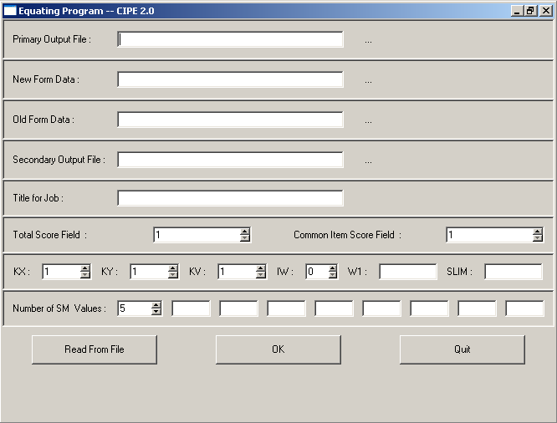

Primary Output File: Name the output file. Use the .txt format.
New Form Data: Data file containing Form X data
Old Form Data: Data file containing Form Y data
Secondary Output File: Output formatted for use in other programs (e.g., Excel, SPSS) Use the .txt format.
Title for Job: Title that prints at top of primary output file
Total Score Field: the field in data file containing the total score
Common Item Score Field: the field in the data file containing the score from common items
KX: Number of items on Form X
KY: Number of items on Form Y
KV: Number of common items
IW: 1 gives you supplemental output; 0 is default
W1: Weight for synthetic population
1 = synthetic population is represented by the new form group
0 = synthetic population is represented by the old form group
-1 = synthetic population is based on groups weighted by sample size
.5 = synthetic population is based on groups weighted equally
SLIM: Smoothing limits parameter (.005 is typical)
Number of SM Values: Smoothing parameters
Followed by up to 8 degrees of smoothing (we will use .10, .25, .50, .75, 1.00)

