5. Organizational Research (drawn from Raudenbush & Bryk, 2002) EPSY 8268

Questions regarding how organizations affect individual.

Level-1 units are persons, and person outcomes are a function of individual characteristics.

Level-2 units are organizations.

Regression coefficients in the level-1 model for each organization are outcome variables that are a function of organizational characteristics.

Generalized Person-Level Model



We consider the level-1 coefficients to be distributive effects – describe how the outcome is distributed in organization *j* via person characteristics.

Generalized Organization-Level Model



Distributive effects of organizational characteristics unique effect

effects in **=** on the distribution of outcomes **+** associated with

organization *j* within organization *j* organization *j*

Each β*qj* becomes an outcome variable that is a function of a set of organizational-level variables and a unique organization effect, *uqj*.

The γ*qs* coefficients capture the influence of organizational variables *Wsj*.

**Case 1 of Organizational Effects**

* Some aspect(s) of the organization have a common influence on persons within the organization, such as resources, structure, climate, etc.
* These aspects affect the mean level of the outcome for the organization.
* The distribution of effects among persons within the organization is unchanged.
* Only β0*j* varies across organizations.

The random-intercepts model







…



School effects on teacher efficacy











Evaluating program effects on writing, based on an intervention to improve writing skill and to enhance self-perception of academic competence







**Case 2 of Organizational Effects**

* Organizational effects can modify the mean level of outcomes and how effects are distributed among individuals.

Complications

* Regression coefficients have greater sampling variability
* Small samples produce unstable estimates
* When individuals within an organization are more alike (homogenous) relative to a random sample, and this reduced variability influence estimation of the association with the outcome.

Social distribution of achievement in public and catholic high schools.

A random-coefficients regression model.











**T** =

|  |  |  |  |
| --- | --- | --- | --- |
| Var(*u*0*j*) |  |  |  |
| Cov(*u*1*j*, *u*0*j*) | Var(*u*1*j*) |  |  |
| Cov(*u*2*j*, *u*0*j*) | Cov(*u*2*j*, *u*1*j*) | Var(*u*2*j*) |  |
| Cov(*u*3*j*, *u*0*j*) | Cov(*u*3*j*, *u*1*j*) | Cov(*u*3*j*, *u*2*j*) | Var(*u*3*j*) |

χ2 tests of the random effects variance components are approximate.

1. Simple univariate tests that do not take into account the other random effects.
2. Estimated only with those organizations with sufficient within-group information to compute the OLS regression.
3. These can be confirmed with the multivariate likelihood ratio test, based on the deviance statistics for nested models (those with fixed versus random variance components).

Creating a model to explore how differences among schools in their organizational characteristics influences the social distribution of achievement within schools.











**Centering Considerations**

***1. Estimating fixed level-1 coefficients***



Figure 5.1.

βw = within-group regression lines (within ellipses)

βb = between-group regression lines (solid line)

βt = total regression (dashed line)

A few characteristics of centering in organization effects research.

* In unbalanced designs, when βb = βw , grand-mean centering is most efficient.
* When βb ≠ βw , grand-mean centering produces an inappropriate estimator of the person level effects. In this case, γ10 is an uninterpretable blend of all three estimators.
* When an unbiased estimator of βw is desired, group-mean centering is appropriate.

***2. Disentangling person-level and compositional effects***

A composition effect, or contextual effect, occurs when the aggregate of a person-level characteristic, ${\overline{X}}_{∙j}$, is related to the outcome, *Yij* , even after controlling for the effects of the individual characteristic *Xij*.

In an OLS regression, we can represent these effects by including both $\left(X_{ij}-{\overline{X}}_{∙j}\right)$ and ${\overline{X}}_{∙j}$:



Formally, the compositional effect is the extent to which the organizational-level association, βb is different than the person-level association, βw.

βc = β2 – β1 = βb – βw

If β2 and β1 are equal, (βb and βw), there is no compositional effect.

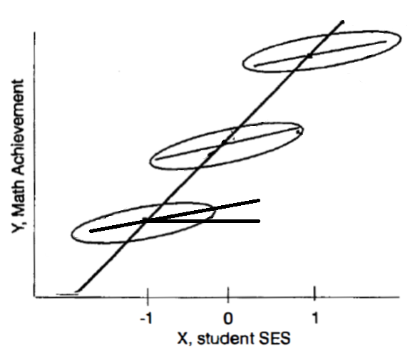

βb

βw

βc

* Three schools, each differ by one unit on X (SES).
* βw is the expected difference on Y for two students within the same school who differ by one unit on SES.
* Βb is the expected difference between the means of two schools that differ one unit in $\overline{SES}$.
* The contextual effect, βc = βb – βw , is the expected difference in outcome (Y) between two students with the same SES, but attend schools that differ by one unit in $\overline{SES}$.

In this case, the contextual effect is the increment to learning to a student because they are educated in school 2 instead of school 1.

Estimating the contextual effect depends on how we center level-1 variables.

* When group-mean centering, the association between X and Y is directly decomposed into within and between components. The compositional effect can be estimated by subtraction.
  + βc = β2 – β1 = βb – βw = , γ01 – γ10
* When grand-mean centering, the compositional effect is estimated directly (γ01). If of interest, βb = γ01 + γ10

Table 5.11

|  |  |
| --- | --- |
| *Group-Mean Centering* | *Grand-Mean Centering* |
|  |  |
|  |  |
|  |  |
|  |  |
| γ01 = βb | γ01 = βc |
| γ10 = βw | γ10 = βw |
| βc = γ01 – γ10 | βb = γ01 + γ10 |

It’s possible that ${\overline{X}}_{∙j}$ acts as a proxy for other relevant omitted organizational variables. It might also convey part of the effect of a poorly measured *Xij*.

***3. Estimating level-2 effects while adjusting for level-1 covariates***

In such an analysis, we should establish that there is no compositional effect. In this case, group-mean centering would not be appropriate.

Notice that in a level-1 model with group-mean centering: 

The influence of X disappears when we evaluate the mean for each group: 

This results a level-2 model that is not adjusted for X: .

Thus, under group-mean centering, the effect of W is not adjusted for X.

In comparison, grand-mean centering at level-1 produces a mean estimate that is adjusted:

 🡪

 🡪

 🡪

 🡪  

***4. Estimating variances of level-1 coefficients***

τ11 is the variance of the level-1 coefficient β1*j*

If every organization has the same mean of X (acknowledging sampling error and missing data), then choice of centering has no effect.

But in organization research, we typically find group means vary across organizations.

1. Persons are usually selected or assigned to the organization, in ways that are associated with X (social class, educational level, etc.) – typically not randomly.
2. Organizations might capitalize on their composition to *create* effects.

In this case, group-mean centering is preferred to properly estimate slope heterogeneity (variance).

* The computation of τ is a function of the empirical Bayes (EB) residual estimates (*u*\*).
* How we center changes the definition of these residuals.
* In group-mean centering, OLS estimates of the intercept experience shrinkage (large when intercept reliability is low); however this does not affect estimation of the slope very much (unless the two are highly correlated).
* In grand-mean centering, means are now adjusted, which can entail an extrapolation (the adjusted mean for group *j* represents the expected outcome for an individual who is at the grand mean on X (perhaps not observed in group *j*). Such adjusted means are less reliably measured. This causes more extensive shrinkage toward the grand mean Y, which produces greater homogenization in slopes. This results in underestimation of τ.
* Generally, EB slope estimates are less credible under grand-mean centering.





***5. Estimating random level-1 coefficients***

As EB estimation may distort variance estimates, there is a similar concern in estimating unit-specific regressions.

* If the level-1 sample size is large for group *j*, OLS and EB estimates converge and this is not dependent on centering method.
* If level-2 sample size is small or moderate, EB estimates tend to be more stable with smaller error than the OLS estimates.
  + If group means of X are invariant across groups, or it’s variance is ignorable, group-mean and grand-mean centering should produce similar results (grand-mean centering may add a little more precision).
  + If the group means of X vary substantially, group-mean centering will produce more robust estimates.