Assessing the Adequacy of the HLM Model EPSY 8268

${\text{MathAch}}_{\text{ij}}=β_{0j}+β_{1j}(\text{SES})_{\text{ij}}+r_{\text{ij}}$ , where r_{ij} ~ N(0, σ²)

$β_{0j}=γ_{\text{00}}+γ_{\text{01}}(\text{Sector})_{j}+γ_{\text{02}}(\text{MeanSES})_{j}+u_{0j}$; where u_{0j} ~ N(0, τ₀₀)
$β_{1j}=γ_{\text{10}}+γ_{\text{11}}(\text{Sector})_{j}+γ_{\text{12}}(\text{MeanSES})_{j}+u_{1j}$; where u_{1j} ~ N(0, τ₁₁)

SES has been centered around the group mean.
SECTOR and MEANSES have been centered around the grand mean.

Standard Data Quality Evaluation

- Examine distributions and summary statistics
  - Identify outliers
  - Consider data transformations if necessary
- Examine simple correlations (look for high degree of multicollinearity)
- Examine the linearity of associations

Convergence

Examining the convergence iterations can be diagnostic. When data are well behaved and are highly informative, convergence should occur rapidly. When there are a large number of random effects and the data are relatively sparse, hundreds of iterations might be needed. Convergence can also take many iterations when variances are near zero (near the boundary of the parameter space). This might indicate it will be more efficient to set random effects to zero – or consider estimating a nonrandomly varying coefficient (include explanatory variables as covariates which explain the variation, so then no residual is estimated).

Robust Standard Errors

These are estimated based on “Huber-corrected” standard errors and apply to designs when the number of highest-level units is large. A comparison between model-based and robust standard errors can signal model specification. For example, when slope heterogeneity exists, but the random effect is fixed to zero, there will be larger discrepancies between model-based and robust SEs. However, when these values are close, it does not suggest “correct” specification, only that the SEs are insensitive to error in the assumptions regarding the covariance structures of the residuals.

Linearity

Scatterplot of EB residuals of the SES slope (EBSES) and a level-2 variable (MEANSES).

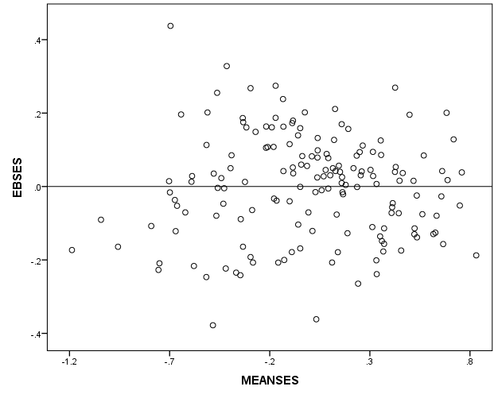

This examines possible nonlinearity of a level-2 explanatory variable to an outcome (slope). The scatterplot suggests that the assumption of a linear relationship between SES slope and MEANSES is appropriate – the residuals are randomly distributed around the zero line across values of MEANSES.

- Level-1 Assumption: r_{ij} ~ N(0, σ²)

- Histogram of MDRSVAR (Level-1 residuals)
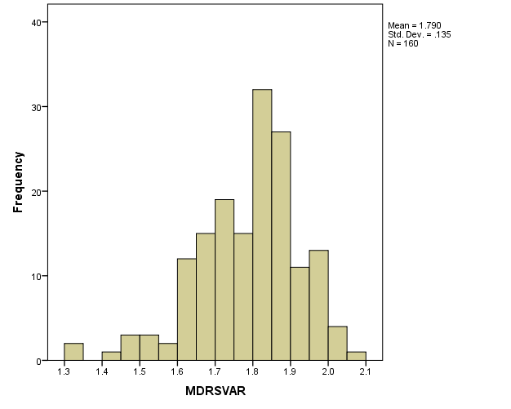
This indicates the Level-1 variances are slightly skewed (there may be outliers near 1.3).

- Normal Q-Q plot of level-1 residuals
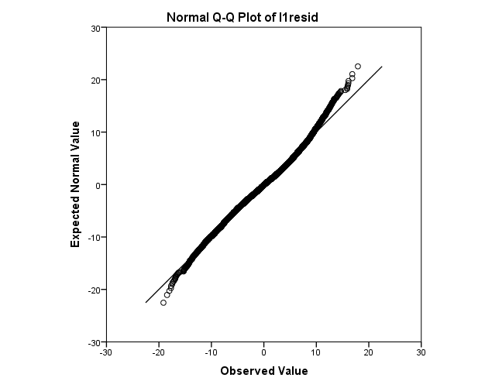
This suggests no significant departure from a normal distribution.

Test of homogeneity of level-1 variance
χ² statistic = 245.76576
degrees of freedom = 159
p-value = 0.000

This indicates the assumption of homogeneity of variance has been violated. We can see the degree to which variances at Level-1 vary in the histogram above (from 1.3 to 2.1).

- Level-1 Explanatory variables are independent of residuals

- Exploratory analysis of Level-1 variables

- Scatterplot of residuals and explanatory variables

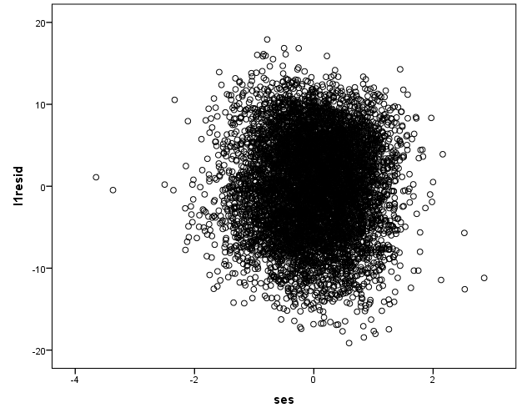
No discernable association between residuals and explanatory variable.

- Correlation matrix of L-1 variables

With only one explanatory variable at level-1, there are no correlations at Level-1.

- Level-2 Normality and Variance Homogeneity

- Histogram of EB intercepts and slopes

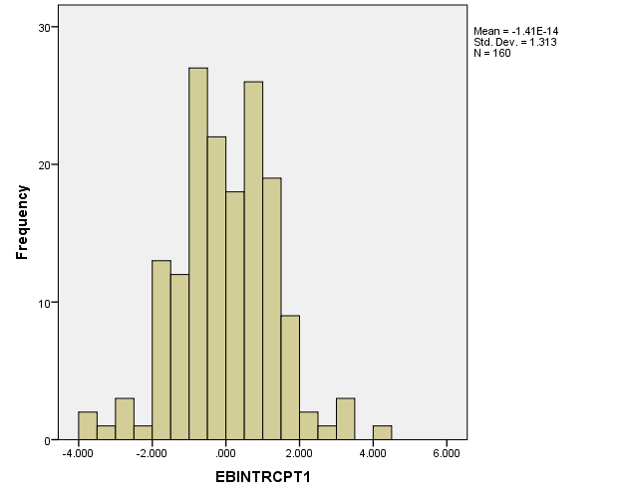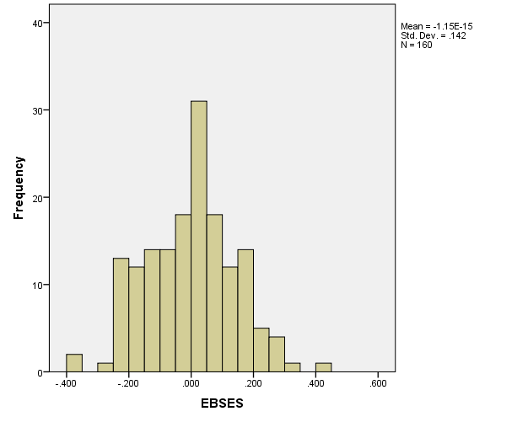

- Histogram of MDIST

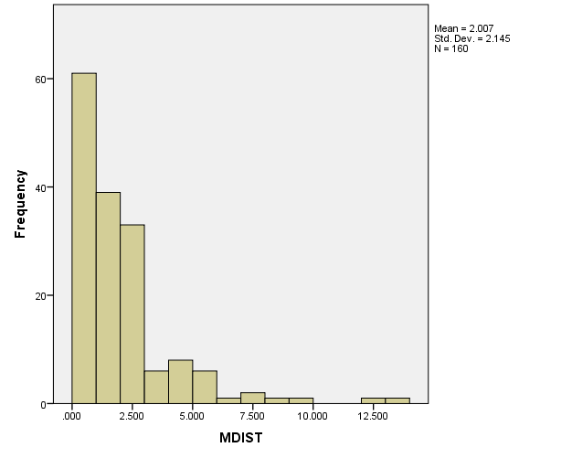

C. Scatterplot of MDIST (Level-2 variance) × CHIPCT (expected χ² values)

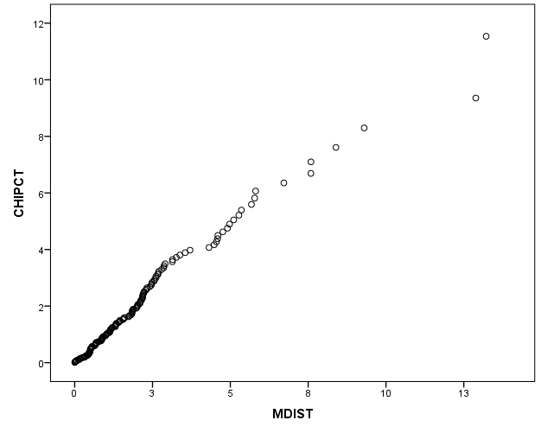

This indicates that the Level-2 variances follow the expected χ² distribution, when plotted against the expected values (CHIPCT). This should be a 45-degree line, when level-1 samples, n_{j} are moderately large.

Descriptive Statistics
 | N | Minimum | Maximum | Mean | Std. Deviation
NJ | 160 | 14 | 67 | 44.91 | 11.855

- Level-2 explanatory variables are independent of residuals

- Scatterplot of EB and FV intercepts

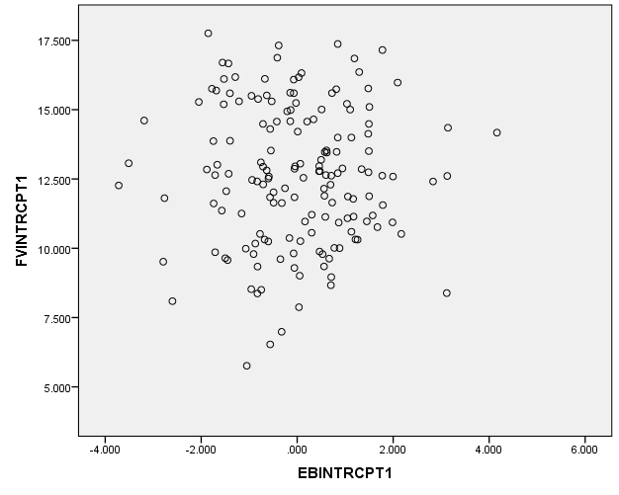

- Scatterplot of EB and FV slopes

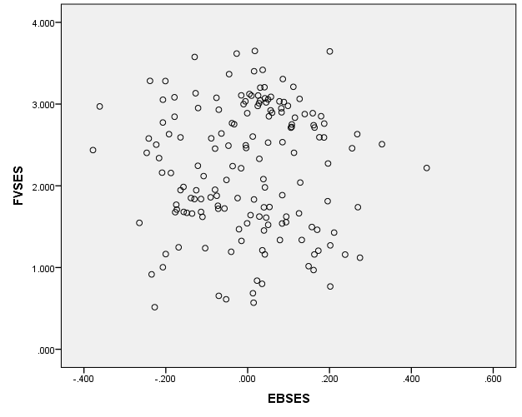

- Correlation matrix of Level-2 Variables

 | SECTOR | MEANSES
SECTOR | 1.000
MEANSES | .355 | 1.000
EBINTRCP | .000 | .000
EBSES | .000 | .000
OLINTRCP | .003 | .012
OLSES | .011 | -.039

This indicates that the two explanatory variables at Level-2 are fairly independent (no multicolinearlity problem is expected) since their shared variance is 13% (.355²).

In addition, the Level-2 explanatory variables are not correlated with the Level-2 residuals (u₀: EBINTRCP, OLINTRCP or u₁: EBSES, OLSES), where all correlations are less than .04.

- Residual independence across levels

- Scatterplot of Level-1 variances with Level-2 variance

Scatterplots of OLSRSVAR with EB intercepts and slopes

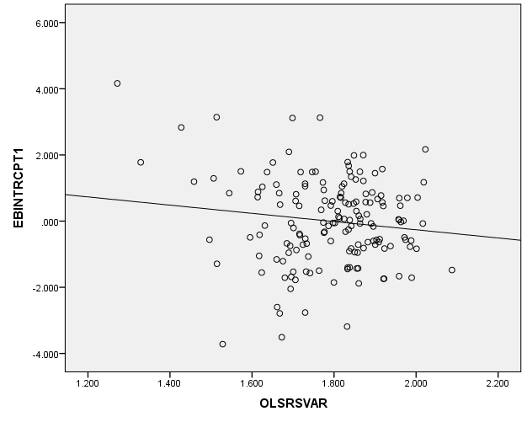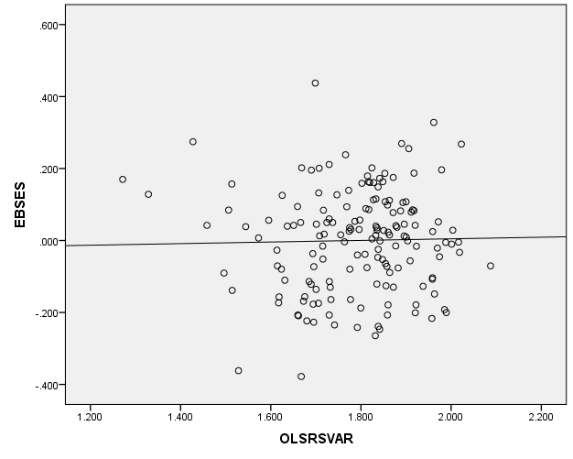

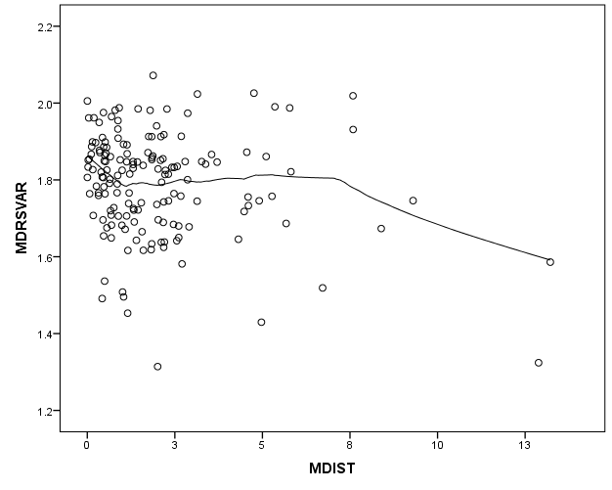

This indicates that the errors at Level-1 (MDRSVAR) are independent of the errors at Level-2 (MDIST). There is no discernable relationship.

OTHER GRAPHING OPTIONS

Box-plots of level-1 outcome distributions for level-2 units.

In the HLM File menu, choose [Graph Data], [box-whisker plots].
Choose the outcome variable in Y-axis option box.
Choose the number of groups.
Below is a sample of 10% from the HSB data.

These can be identified by an explanatory variable.
Below is a sample of 30% of schools from HSB data, identified by MEANSES.

Another example includes 30% of HSB schools, identified by SECTOR (red for Catholic schools, blue for public schools).

Line Plots for two-level analyses

These plots are particularly useful for longitudinal or growth models. The examples are based on the VOCABL1.SAV and VOCABL2.SAV data in the example data files from HLM (the data folder for Chapter 18).

When the MDM file is opened (create new model using an existing MDM), in the File menu:
Choose [Graph Data], [line plots, scatter plots].
Select the X-axis Time variable (AGE in this example) and the Y-axis outcome (VOCAB)
Select the number of groups, type of plot, and pagination
The example below is Line Plot/Straight line, all groups on same graph

This can also include a level-2 (individual) characteristics, such as sex. Below (Female is red, male is blue).

Model Graphs for two-level models

Specify a full HLM growth model. Run the model. Examples here are based on EGs.
Choose [Basic Settings], which opens the Basic Model Specifications dialog box.
Enter a name for the graphics file associated with the data and model.
Enter a title and name the output file. Save the command file and run the model.
Open the File menu and choose [Graph Equations] and [Model Graphs]
X focus: Select the time variable for Level-1
Select [Entire range] for range of x-axis

There are options for Range/Title/Color and Other settings that can be set.
Select the Z focus Level-2 variables. You can set the range for the variables for the display

This graph illustrates the main effect of Student-of-Color (SOC, distance between red and blue lines) and the nonsignificant effect of SES on the intercept (nonsignificant distance between dashed and solid lines within color), but no difference in slopes given SOC or SES. This is confirmed by the table of final effects below.

Final estimation of fixed effects:
Fixed Effect | Coefficient | Standard error | t-ratio | Approx. d.f. | p-value
For INTRCPT1, π₀
INTRCPT2, β₀₀ | -0.266235 | 0.199138 | -1.337 | 347 | 0.182
SOC, β₀₁ | -0.614399 | 0.248242 | -2.475 | 347 | 0.014
SES, β₀₂ | 0.121497 | 0.103066 | 1.179 | 347 | 0.239
For YEAR slope, π₁
INTRCPT2, β₁₀ | 0.827458 | 0.062165 | 13.311 | 347 | <0.001
SOC, β₁₁ | -0.090339 | 0.078289 | -1.154 | 347 | 0.249
SES, β₁₂ | -0.013695 | 0.032844 | -0.417 | 347 | 0.677

Level-1 Equation Modeling

The example here uses EGs data, as above.
After the model is run, select [Graph Equations], [Level-1 equation graphing]
Specify X focus for the Time variable and other settings

Below is the same graph with SOC indicated by color (red is Student of Color).

Another example is from the IGDI 2.0 measures of Rhyming. In this study, children are measured at different points in time and a different number of time points – based on Age which was centered at 60 months old.

This graph illustrates about 260 children in the sample, where children are measured three time points at different ages. We also see a correlation between intercepts and slopes. Children with lower abilities overall also have lower slopes. This is consistent with the HLM results:

τ (as correlations)
INTRCPT1,π₀ | 1.000 | 0.784
AGE60,π₁ | 0.784 | 1.000

Below is the same graph with ELL indicated by color (red is English Language Learner).

There is no discernable difference in ELL status; this is confirmed with the fixed effects results from the HLM analysis.

Final estimation of fixed effects:
Fixed Effect | Coefficient | Standard error | t-ratio | Approx. d.f. | p-value
For INTRCPT1, π₀
INTRCPT2, β₀₀ | 1.362303 | 0.089250 | 15.264 | 379 | <0.001
For AGE60 slope, π₁
INTRCPT2, β₁₀ | 0.132248 | 0.012757 | 10.367 | 378 | <0.001
ELL, β₁₁ | 0.006655 | 0.023756 | 0.280 | 378 | 0.780

In addition, there appears to be substantial variation in slopes, which is confirmed with the random effects variance components.

Final estimation of variance components
Random Effect | Standard  Deviation | Variance  Component | d.f. | χ² | p-value
INTRCPT1, r₀ | 1.54061 | 2.37348 | 345 | 1508.02193 | <0.001
AGE60 slope, r₁ | 0.09457 | 0.00894 | 344 | 421.86133 | 0.003
level-1, e | 0.92402 | 0.85381

